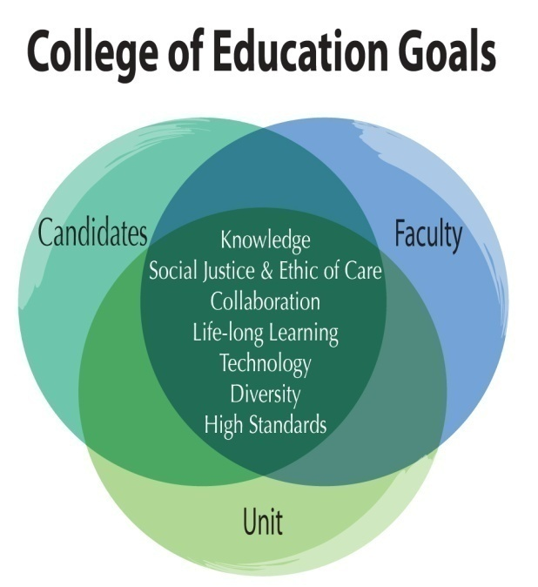

Table 4: Phases of the Continuous Improvement Model

|  |  |  |
| --- | --- | --- |
| ***Phase 1 – Data Analysis & Needs Assessment (August-September)*** | | |
| **Candidate Proficiencies (Program Faculty)** | **Faculty Expectations (Individual Faculty and Mentors, as applies)** | **Unit Expectations (College Leadership Team)** |
| Program review of previous year candidate and alumni data. Identify program needs. Results shared with faculty and administration. | Individual faculty review of previous year course assessments, program needs, and previous Annual Review of teaching, scholarship & service. | Administrative review of data on unit operations, program needs, external reports, strategic plan, resources, and faculty needs. |
| ***Phase 2 – Improvement Planning (September-October)*** | | |
| Program faculty develop and submit *Program Improvement Plans* to address candidate needs. Gather input from program advisory boards. | Develop and submit individual *Professional Development Plans* for teaching, scholarship, & service. | Develop annual *College Improvement Plan* and update the strategic plan. Gather input from the College Advisory Board. |
| ***Phase 3 – Implementation & Formative Assessment (September-April)*** | | |
| Implement program improvement plans and collect formative data on candidate progress. Prepare program revision documents for curriculum committee approval. | Implement professional development plan activities and collect data in areas of teaching, scholarship, and service. | Implement college improvement plan and collect data. Support and monitor data collection for program and faculty development activities. |
| ***Phase 4 – Annual Review & Reporting (March-June)*** | | |
| Review formative data and develop the annual *Program Review Report* describing program accomplishments and submit to faculty, stakeholders, and administration. | Review success in meeting objectives set forth in PDP. Develop an Annual Review involving a portfolio of accomplishments for submission to supervisor. | Review candidate, program, and faculty reports of achievement. Develop *Annual College Report* and review with College Advisory Board. |
| ***Phase 5 – Data Aggregation & Statistical Analysis (June-August)*** | | |
| Aggregate, disaggregate, and analyze candidate performance data in preparation for annual needs assessment. | Aggregate teaching, scholarship, and service data from all faculty across the college. | Aggregate, disaggregate and analyze data related to unit operations in preparation for annual needs assessment. |