**Appendix II E**

**Student Assessment of Instruction (SAI)**

Overview

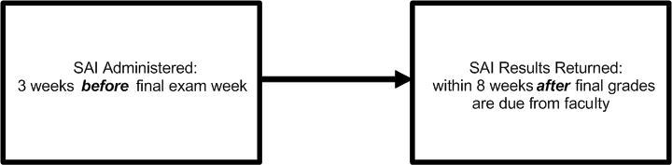

FGCU SAI is administered every Fall and Spring semesters to all lecture courses that have an enrollment of 6 or more students*. Three weeks before final exams, instructors who lecture in computer classrooms and Distance Learning sections will have the online version of the SAI activated, and those instructors who lecture in non-computer classrooms will receive an envelope in their mailboxes containing all instructions and materials (except for pencils or pens) needed to administer the paper version of the SAI.

Early in the semester, each instructor will be sent an email that includes a link to a course verification page and a deadline for updating their information. From the verification page the instructor can update the enrollment number and change from the paper version of SAI to the online version. However, instructors cannot change assessment type from online to paper. For courses set as “No Assessment” an alternative assessment might be developed by contacting the [Assistant Director of Assessment](http://www.fgcu.edu/planning/studentassessment/FacultyInfo/Information/FacultyInstructions.html).

For the College of Health Professions, packet request forms must be completed for each packet. Faculty are required to provide us with accurate course information as well as their choice for assessment type.

**IMPORTANT:** It is the ***instructor’s responsibility*** to read all email coming from the Office of Planning and Institutional Performance, so that all deadlines are met and instructions are followed.

When administering the FGCU SAI, care must be taken to choose a day when a test or final exam is not given; a day that is not after the deadline. Paper results of the SAI will be returned to each instructor within 8 weeks after final grades are due from faculty. Instructors will get a summary report. Those instructors who administer the paper version of the SAI will also receive the original forms that the students filled out at the time of administration.

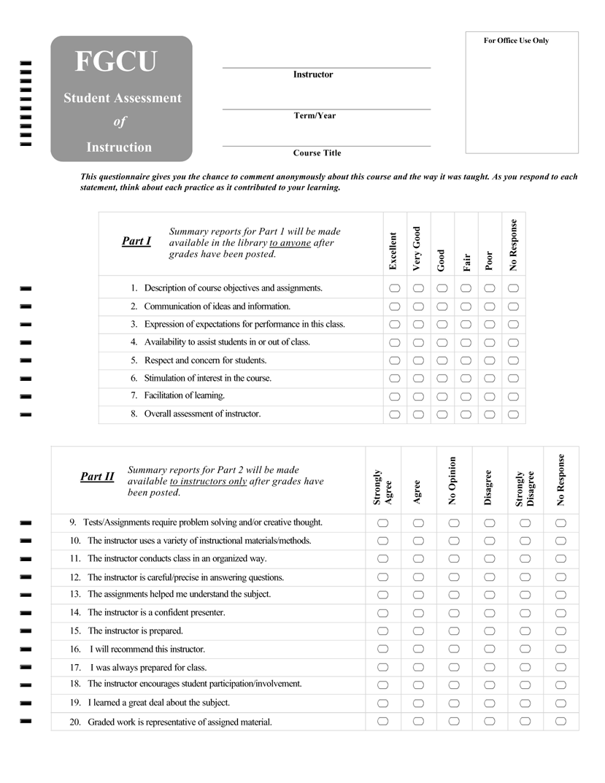

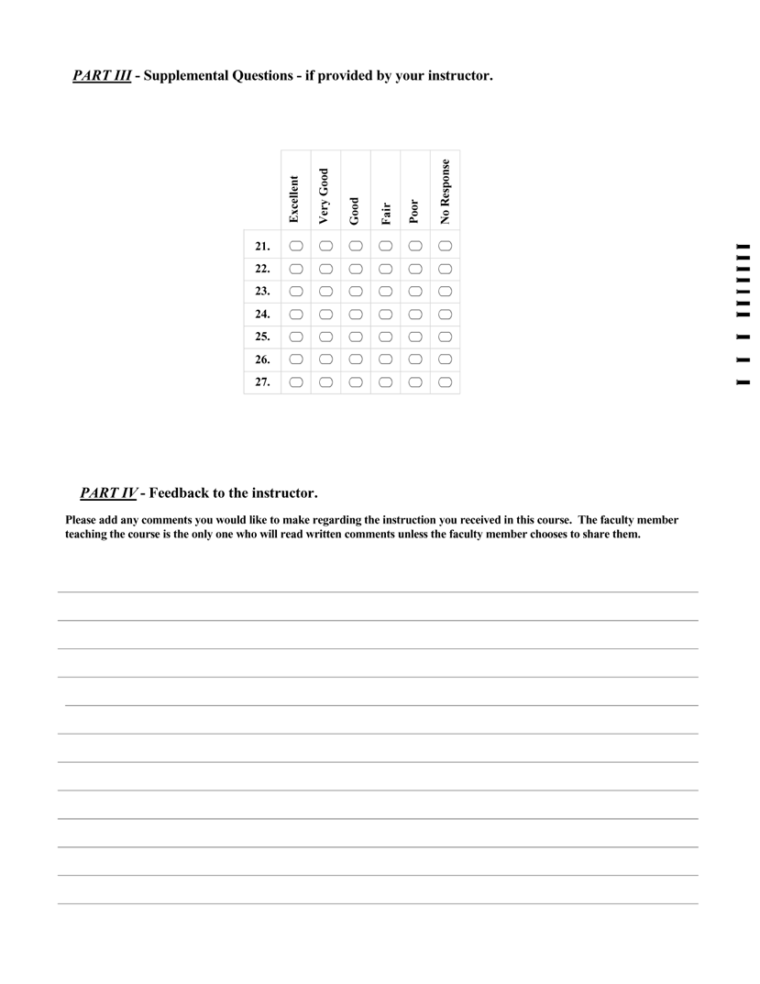

SAI Results by Faculty Average based on a range of 1 = Low to 5 = HIgh

|  |  |  |  |  |  |  |  |
| --- | --- | --- | --- | --- | --- | --- | --- |
| Semester | All COE Faculty | Davis | Finn | Isaacs | Kastberg | Sabella | Dimidjian |
| Fall 2001 | 4.41 |  |  | 4.42 |  | 4.53 |  |
| Spring 2002 | 4.34 |  |  | 4.29 |  | 3.84 | 3.39 |
| Fall 2002 | 5.24 | 3.80 |  |  |  | 4.12 | 3.57 |
| Spring 2003 | 4.49 | 3.98 |  | 4.38 |  | 4.53 | 4.00 |
| Fall 2003 | 4.22 | 4.21 | 3.85 | 4.83 |  | 4.34 | 3.85 |
| Spring 2004 | 4.38 | 4.00 | 2.50 | 4.58 |  | 4.54 | 4.70 |
| Fall 2004 | 4.35 | 4.13 | 4.11 | 5.00 |  | 4.88 | 4.32 |
| Spring 2005 | 4.40 |  | 4.50 | 4.80 |  | 4.80 |  |
| Fall 2005 | 4.30 | 4.30 | 4.05 | 4.70 |  | 4.85 |  |
| Spring 2006 | 4.30 | 4.50 | 4.20 | 4.58 |  | 4.30 |  |
| Fall 2006 | 4.10 | 4.15 | 3.53 | 4.80 |  |  | 3.33 |
| Spring 2007 | 4.20 | 4.50 | 4.10 | 3.80 |  | 4.60 | 3.75 |
| Fall 2007 | 4.20 | 4.70 | 3.30 | 4.45 |  | 4.30 | 3.20 |
| Spring 2008 | 4.30 | 4.65 | 3.80 | 4.30 |  | 4.50 | 3.20 |
| Fall 2008 | 4.30 | 4.55 | 4.00 | 4.25 |  | 4.70 |  |
| Spring 2009 | 4.30 | 3.55 | 4.10 | 4.70 |  | 4.80 |  |
| Fall 2009 | 4.10 |  | 4.20 |  |  | 4.70 |  |
| Spring 2010 | 4.20 |  | 4.40 | 4.20 |  | 4.85 |  |
| Fall 2010 | 4.40 |  |  | 4.20 |  | 4.75 |  |
| Spring 2011 | 4.20 |  | 3.70 | 4.40 |  | 4.60 |  |
| Fall 2011 | 4.20 |  | 4.25 | 3.95 | 3.80 | 4.60 |  |