Appendix III AA program Improvement Example SACS Case Study
SACS Case Study
Counseling Program

Florida Gulf Coast University
College of Education

Description of the Program 1
Counseling Program Mission 1
Courses 2
MA: Mental Health Counseling 2
Plan 1 - MEd School Counseling (48 hours): 2
Field Experiences 3
Uniqueness of the FGCU Counseling Program 4

Student Outcome Case Study 6
Counselor Preparation Comprehensive Examination (CPCE) 6
CONTENT OF THE CPCE 6
Format of the CPCE 7
What student outcomes were assessed? 8
How was the assessment conducted? 8
Who took part in the assessment? 8
Who analyzed the results? 8
How were the results analyzed? 8
What were the results? 8
Descriptive Statistics of CPCE Results 9
Differences in CPCE Results by Program 9
CPCE Results Over Time 9
CPCE Results Over Time for Each Section 11

Comparison of FGCU Results with National Norms 16

Program Improvements 20
How do we know the change was effective? 21

Other Updates to the Program 21

Description of the Program

Counseling Program Mission

The FGCU Counseling Program advances ethical and moral practice among counselors as well as continue contributions to the advancement of the profession. This program takes a life-span developmental perspective and maximizes the quality of life among its clients/students in their respective environments/systems. Our program allows students to experience a wide breadth of counseling philosophies and techniques while assisting them to adopt a personally meaningful, integrated, and useful approach. Our program trains students according to the highest known professional standards and practice as developed by continued research and practical experience. The FGCU Counseling program holds its students accountable to themselves, their clients/students, and to their profession. Both faculty and students complete their work with integrity, honesty, perseverance, respect, competence, and compassion.

Finally, based on the philosophy of the University, the program, and individual faculty, we have identified a set of professional values that we believe are at the heart of our profession. By helping students understand the importance of recognizing their own values and the impact these values have on the clientele they serve, we promote reflective practice and the following values in addition to those listed above

- Advocacy for the profession as well as for individuals and groups; especially those who have been underrepresented in society.
- A respect for the inherent worth of all human beings.

Beginning professional counselors who graduate from the Counseling program at Florida Gulf Coast University has knowledge, skills and dispositions commensurate with the needs of the population they serve. The standards established by the Council for the Accreditation of Counseling and Related Educational Programs (CACREP) provide a nationally recognized set of core competencies for our program.

Therefore,

The mission of Florida Gulf Coast University's (FGCU) Counseling Program is to prepare exemplary professional practitioners, leaders, and scholars. The program uses a research-practitioner approach that integrates the use of current technology, supervised field experiences, scholarly inquiry, and intellectual and creative resources to work with an increasingly diverse and global society. The program trains counselors who work in pre-K through grade 12 schools, social service, government agencies, hospitals, community organizations, and private practice. The FGCU counseling program educates well-rounded counselors who demonstrate competence included in the high standards as set forth by our accreditation and professional organizations.

Courses

MA: Mental Health Counseling
MHS 6021 Introduction to Community Mental Health (3)
MHS 6055 Lifespan Development (3)
MHS 6070 Mental Disorders (3)
MHS 6200 Appraisal Procedures (3)
MHS 6340 Career Development (3)
MHS 6404 Introduction to Counseling Theory and Technique (3)
MHS 6405 Advanced Counseling Theory (3)
MHS 6428 Cross-Cultural Counseling
MHS 6450 Issues in Addictions and Abuse (3)
MHS 6480 Human Sexuality (3)
MHS 6500 Intro to Group Dynamics (3)
MHS 6621 Organizations, Administration, and Supervision (3)
MHS 6740 Research & Program Evaluation (3)
MHS 6780 Legal & Ethical Issues for the Counseling Profession (3)
MHS 6800 Practicum in Counseling (3)
MHS 6805 Advanced Practicum in Counseling (3)
MHS 6881 Clinical Internship I (2)
MHS 6882 Clinical Internship II (2
MHS 6883 Clinical Internship III (3)
MHS 6888 Clinical Internship and Prof Dev Seminar in Mental Health Counseling (3)
MHS 6886 Clinical Internship V (2)

Plan 1 - MEd School Counseling (48 hours):
MHS 6010 Introduction to School Counseling (3)
MHS 6051 Human Development for School Counselors (3)
MHS 6200 Appraisal Procedures in Schools (3)
MHS 6340 Career Development (3)
MHS 6400 Counseling Theory for School Counselors (3)
MHS 6401 Advanced School Counseling Methods (3)
MHS 6500 Group Work for School Professionals (3)
MHS 6601 Consultation & Collaboration Problem Solving (3)
MHS 6605 Special Needs Counseling & Consultation (3)
MHS 6720 Seminar in Professional Development and Supervision (1)
MHS 6740 Research & Program Evaluation (3)
MHS 6780 Legal & Ethical Issues in the Counseling Profession (3)
MHS 6800 Practicum in Counseling (3)
MHS 6805 Advanced Practicum in Counseling (3)
MHS 6831 Internship I (2)
MHS 6832 Internship II (3)
SDS 6830 Internship in School Counseling (3)

Plan 2 - MA School Counseling without prior teacher certification or eligibility (57 hours):
The following two courses are taken in the semester prior to joining the cohort.

EDF 6259 Classroom Management & Organization (3)
EDG 4620 Curriculum and Instruction (3)
RED 5147 Developmental Reading

As noted above, both the Mental Health and School Counseling programs are housed in the graduate studies division of the College of Education. All courses offered by the program and required for graduation are offered at the graduate level (with the exception of Curriculum and Instruction required for school counseling students who enter the program without prior teaching preparation or credential.) All counseling courses are offered by counseling core faculty or selected counseling adjuncts and courses in research, classroom management, and curriculum and instruction are taught by qualified doctoral trained faculty in the College of Education. Neither program concentration allows for elective courses.

All other requirements for School Counseling listed above in Plan 1.

Field Experiences

Since the counseling program's inception, a tradition and belief (one that pervades the program's philosophy today) emerged and was embraced that enunciated and demonstrated a keen commitment to providing consistent, progressive, and holistic practicum and internship experiences for program students. The counseling program faculty created, sponsors, and delivers a program regimen that initially, gradually, introduces students to field experiences (i.e., practicum), provides constant supervision and feedback, and culminates in activities (i.e., internship) that immerses students in the professional world of school and mental health practitioners, while providing close, individual feedback and supervision throughout. As the program has developed and matured (although yet in its early stages), counseling faculty members continue to recognize and value the inherent and integral nature of varied, and closely monitored clinical instruction as we prepare effective and responsible counselors to serve meaningfully in the lives of other human beings.

As field experiences are viewed as developmental in nature, the program is designed as a gradual immersion process for counselors-in-training. Counseling students must initially successfully complete practicum and advanced practicum courses prior to participating in internship activities). Any, and all, advanced students who serve as individual or group supervisors have or are in the process of completing a counseling supervision course. In fact, in the program's design, Mental Health students in their last term of study who are completing Organization, Administration and Supervision (MHS 6621) act as supervisors to the Advanced Practicum students in their first year of study. These supervision students complete a supervised internship (MHS 6886) in supervision concurrent with their course.

As site supervisors are deemed critical to the successful preparation of counselor trainees, site hosts are carefully screened and prepared to serve as site supervisors. Annually, the counselor education faculty conducts a Site Host Appreciation/Orientation meeting at which program faculty express our sincere gratitude for the invaluable role site hosts assume in the lives and training of our students. Also, at the Site Host Appreciation/Orientation meeting, site supervisors are introduced to, among others, the program faculty, program philosophy, program curriculum, and program faculty expectations. At the Appreciation/Orientation meeting, site hosts are provided with a student and site host internship manual, and vital information critical for them to serve successfully as internship supervisors. We advise them that in order to serve as a site host, the site supervisor must have:

- Minimum of a Master's degree
- A minimum of two years of professional experience
- A commitment to providing a minimum of one hour of weekly on-site supervision for trainees
- Proper training in supervision protocol

All sites and supervisors are evaluated by participating students at the end of each field experience.

Uniqueness of the FGCU Counseling Program

In addition to requiring supervised field experiences throughout the curriculum, the FGCU Counseling program is proud of other unique features of our curriculum layout and design. This includes course implementation and scheduling (cohort model); use of technology; and competencies for becoming effective advocates.

Course Implementation and Scheduling: All counseling students are members of a group cohort which then adheres to an established schedule. The schedule of courses entails a logical and sequential set of courses, each of which provides foundational knowledge and skills for subsequent courses. The advantage of the cohort model includes the close working relationships forged among students and faculty. Also, the use of cohorts allows for faculty to decrease unnecessary repetition due to varied student schedules and classroom experiences. Some exceptions may exist such as when the student completes the program at a different rate.

Use of Technology: Florida Gulf Coast University has been developed as a dynamic higher educational organization for Southwest Florida to prepare students to compete and excel in a world characterized by constant change, high levels of technology, and increased internationalization. To this end, valuable resources promote the integration of technological literacy and adaptation to the world of counseling. For instance, FGCU offers the following (see http://itech.fgcu.edu/):

Open Classrooms -Computer conferencing, electronic mail, and voice mail applications that allow students to communicate with faculty and each other around the clock, allowing a new freedom of discussion, questioning, and clarification even in large enrollment courses.

Community Partnerships - Electronic links that extend the campus to community partners such as public schools, health centers, business and industry, government and non-profit agencies, cultural facilities and library resources.

Open Information Access - University information databases that are available for students and faculty to access and update, as authorized, allowing for more convenient and efficient services such as off-site registration, financial aid and admissions processing, and grade reporting; and that are tailored for enrolled and prospective students and faculty to access through personal computers, touch-tone phones, and the Internet.

The ANGEL Learning Management Suite of teaching and learning tools enables efficient and effective development, delivery and management of courses, course content and learning outcomes. Engaging communication and collaboration capabilities enhance instruction to deliver leading edge teaching and learning. Counseling faculty use ANGEL to facilitate learning by developing online and hybrid (combination of online and live) courses.

LiveText's Accreditation Management System™ provides institutions with the most advanced, complete, and user-friendly web-based tools for developing, assessing, and measuring student learning and more. With LiveText's Accreditation Management System, institutions can provide its students, faculty, administration, and stakeholders the best assurance of its commitment to accountability, continuous improvement, and excellence in education. Counseling students will be required to purchase a license for LiveText in their first course.

Advocacy: A social and professional advocacy model is built on the philosophy that professionals take individual or collective action to correct injustices or to improve conditions for the benefit of an individual, group, or the profession as a whole. Preparing counselors to be social and professional advocates has long been encouraged in the counseling profession. Vital social, cultural, and professional issues call for counselors to understand and implement change strategies. The Counseling program has integrated the skills, knowledge, and attitudes necessary for effective advocacy among its counseling students.

Student Outcome Case Study

As a requirement for graduation, all students in the counseling program must take and pass the Counselor Preparation Comprehensive Examination (CPCE) also known as the Exit Exam.

Counselor Preparation Comprehensive Examination (CPCE)

The CPCE is researched, developed, and distributed by both the Research and Assessment Corporation for Counseling (RACC) and the Center for Credentialing and Education (CCE), two affiliate corporations of the National Board for Certified Counselors (NBCC). The item writing committee was selected from master's and doctoral level professionals. The committee compiled a comprehensive listing of texts used in counselor education programs. Each question was developed based on information found in the most commonly used textbooks.

CONTENT OF THE CPCE

The CPCE covers the eight common-core areas from the Council for Accreditation of Counseling and Related Educational Programs (CACREP) as defined by their Standards for Preparation. These eight core areas serve as the primary theoretical basis for the examination. It is through these areas that the CPCE is associated with accepted professional standards.

1. Human growth and development - studies that provide an understanding of the nature and needs of individuals at all developmental levels.

2. Social and cultural foundations - studies that provide an understanding of issues and trends in a multicultural and diverse society.

3. Helping relationships - studies that provide an understanding of counseling and consultation processes.

4. Group work - studies that provide an understanding of group development, dynamics, counseling theories, group counseling methods and skills, and other group work approaches.

5. Career and lifestyle development - studies that provide an understanding of career development and related life factors.

6. Appraisal - studies that provide an understanding of individual and group approaches to assessment and evaluation.

7. Research and program evaluation - studies that provide an understanding of types of research methods, basic statistics, and ethical and legal considerations in research.

8. Professional orientation and ethics - studies that provide an understanding of all aspects of professional functioning including history, roles, organizational structures, ethics, standards, and credentialing.

These eight core areas serve as the primary theoretical basis for the examination. It is through these areas that the CPCE is associated with accepted professional standards.

Format of the CPCE

The CPCE consists of 160 items with 20 items per CACREP area. Of the 20 items per section, 17 will be scored; the remaining three will be pretest items that are not identified to the student. The purpose of imbedded pre-testing is to generate actual score performance data on items. This allows CCE to select items for future test construction that have the most desirable psychometric attributes. Scores for each section and a total score will be reported for each student. The CCE provides statistics on the program's students as well as national data. Each institution is responsible for determining a minimum criterion score for their students.

What student outcomes were assessed?

The eight core areas described by CACREP (see above).

How was the assessment conducted?

Once per year in Mid October with March reserved for retakes, students sign up to take the exam if they are within one semester of graduation. The test is ordered from the CCE and administered according to CCE test administration policies and guidelines.

Who took part in the assessment?

All students must take the CPCE as a requirement for graduation. All program faculty share responsibilities for preparing students to succeed on the exam which includes the same competencies addressed throughout our courses.

Who analyzed the results?

The exam is scored by the CCE who provides number of correct responses for each of the eight areas of counseling and a total score. The CCE also provided national norm data for each administration of the exam. Program faculty collaborate on further analysis as described below.

How were the results analyzed?

After removing all retake data (i.e., students who do not pass must take the exam again until they do meet the minimum passing score of 90 correct for a first administration and minimum 95 for second or subsequent administrations), faculty drilled deeper into the performance data and conduct analyses such as:

- Disaggregating and comparing results by program (i.e., mental health counseling and school counseling).
- Compare FGCU counseling program student results to national norms.
- Compare performance for all eight areas across time (we now have data for the last 10 years).

What were the results?

Following are the descriptive statistics for the exam since 2001 (with the exception of 2007 during which too few students took the exam to be included in the analysis). During 2008, the initial case study was completed. The initial analysis pointed to four areas in which students performed lowest: Career and lifespan development, Appraisal, and Research and Program Evaluation (see chart below). This report now reflects an updated review which includes data from the last two years (2009-2010).

During the initial case study analysis, it was determined that there is no statistically significant difference in CPCE exam results by counseling program. That is, an independent samples T-test showed that there is no significant difference for how students in the school counseling program performed as compared to the mental health counseling students. Continued analysis for each administration of the exam in recent years also shows no differences.

CPCE Results Over Time

Over time, the total average scores and mean scores for each section show no particular patterns (see charts below) with the exception of the most recent administration. Both FGCU and National norms were much lower for every subsection and as a total than in previous and recent years. Each set of scores were examined against national norms as.

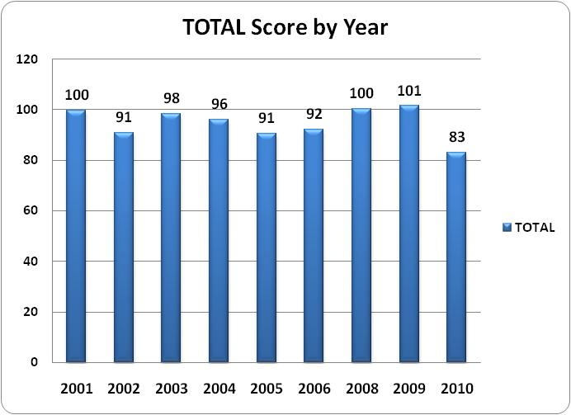
Average CPCE Results Over Time for Each Section

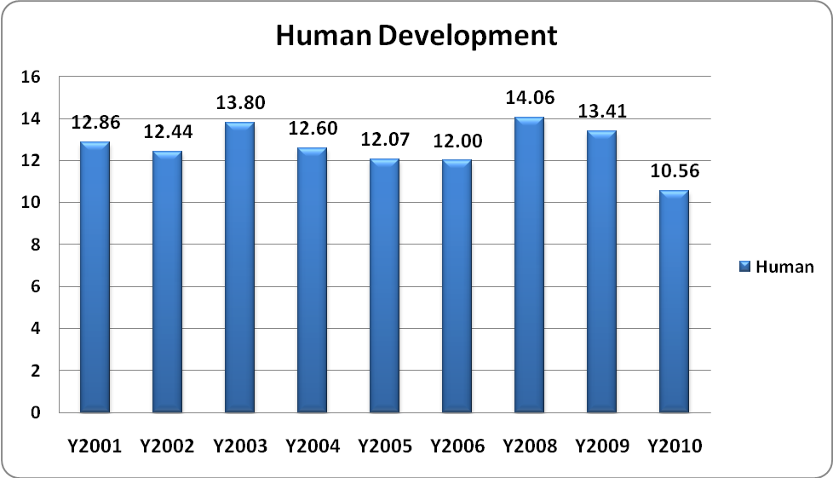

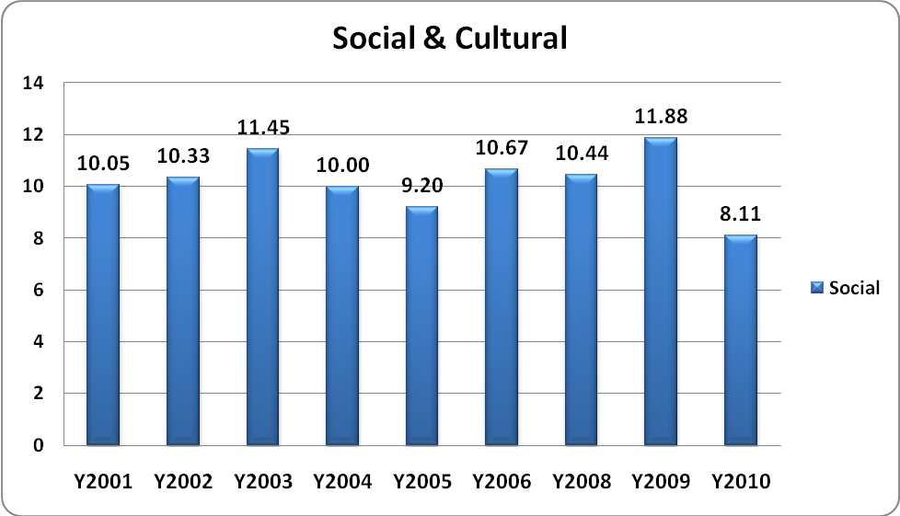

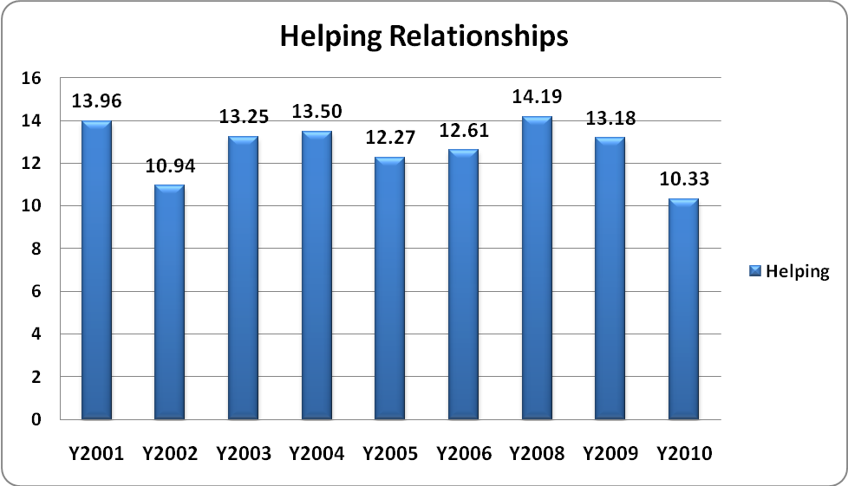

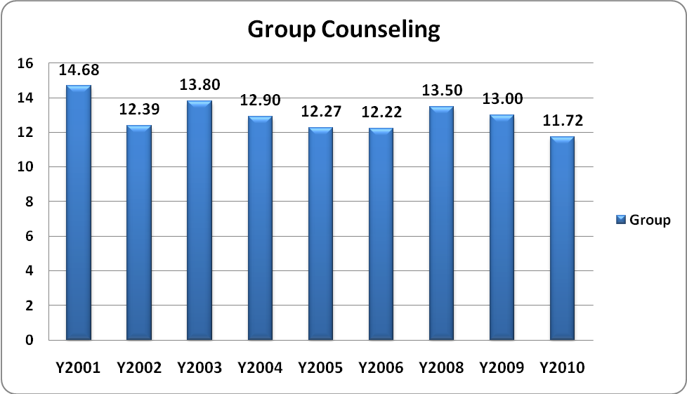

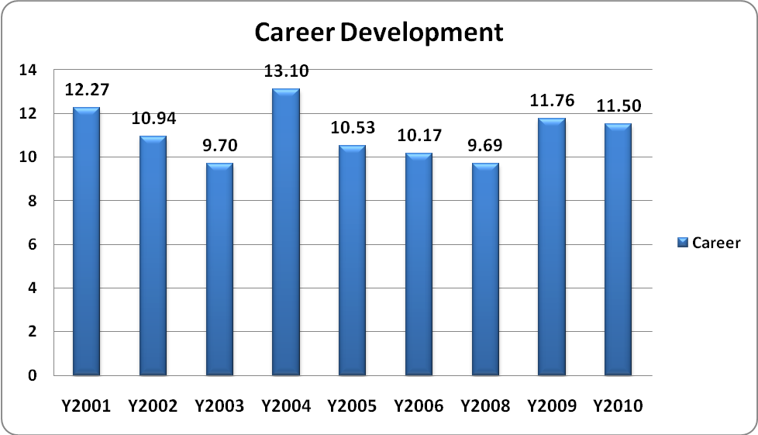

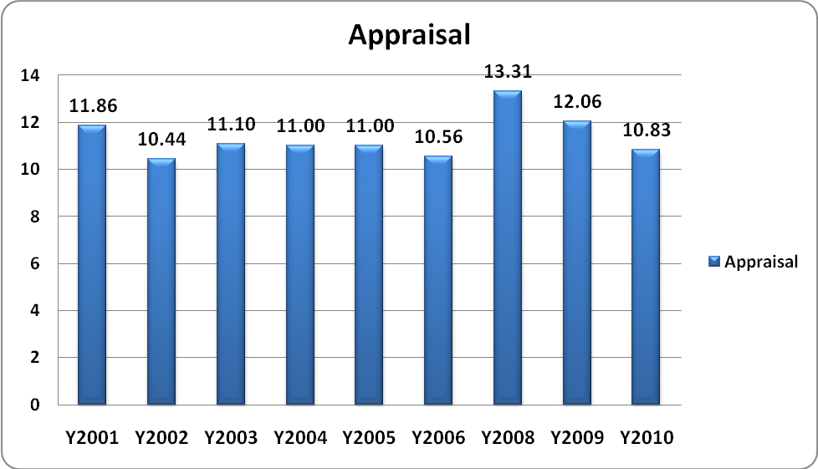

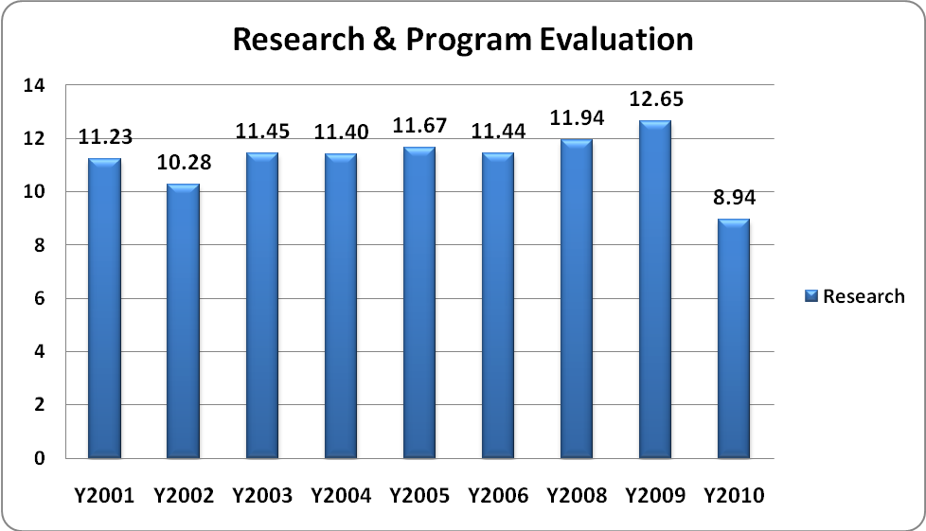

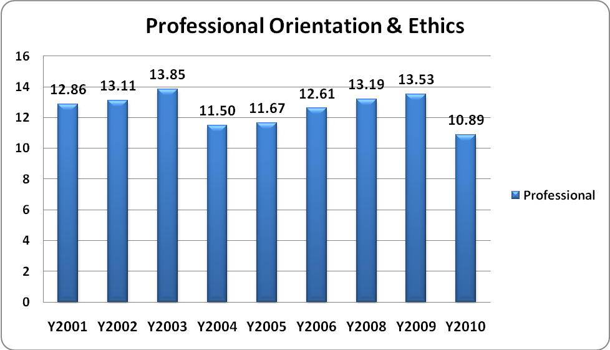
Comparison of FGCU Results with National Norms

To derive greater meaning from our student performance scores on the CPCE, each subscale or section was compared to the national norms. It was determined that, overall, in four areas, our students perform on average with the other students taking the exam throughout the country. In the other four areas, they score higher than the national norms. We also determined that although the subscore in the area of Career Development seems to be significantly lower than in the other areas, these scores mirror national norms, and in fact, our students performed above the national norms in the area of Career Development (see charts below).

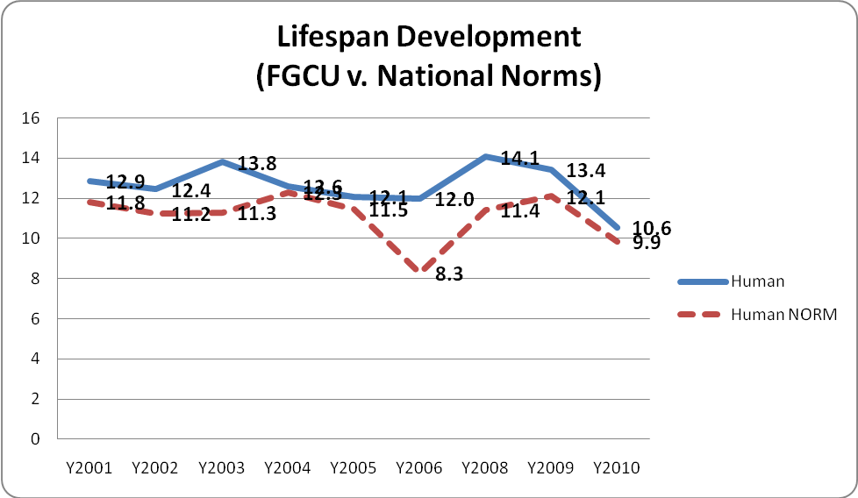

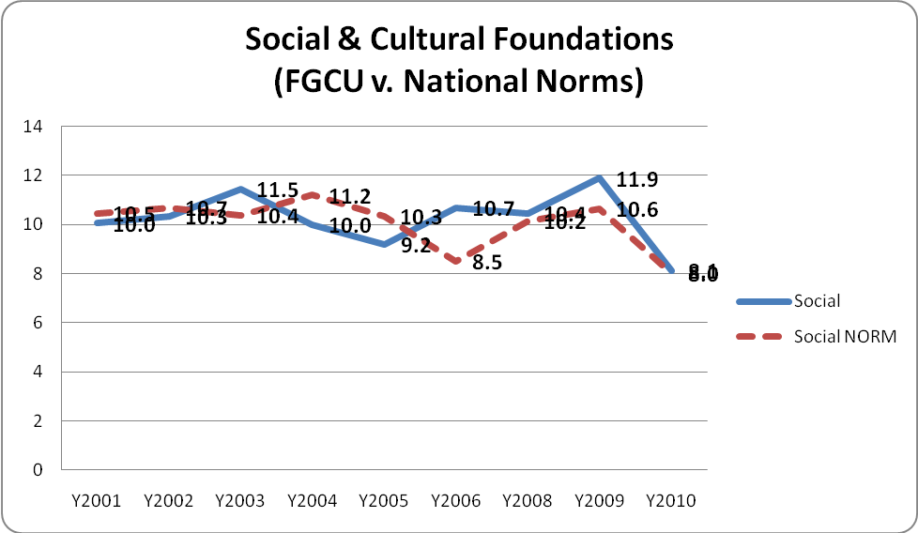

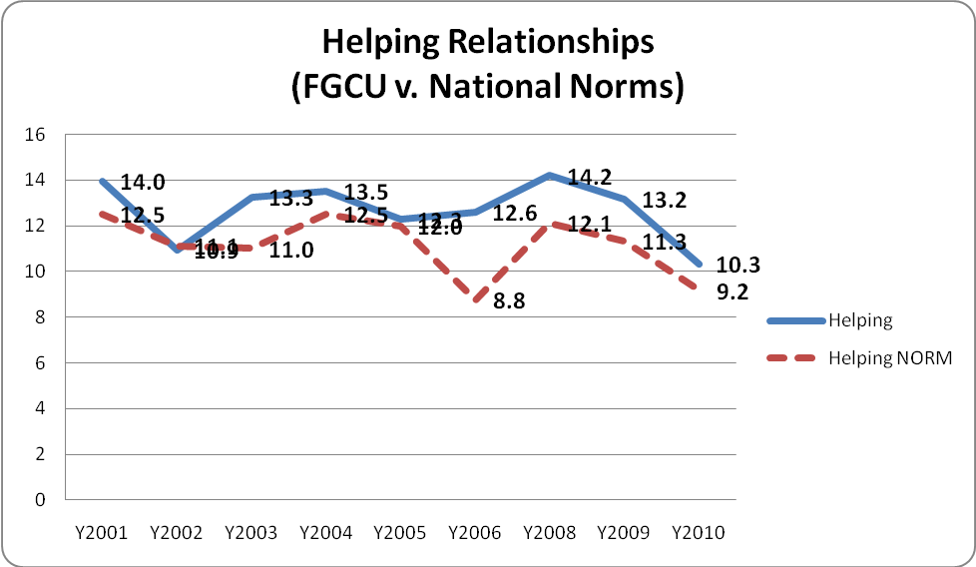
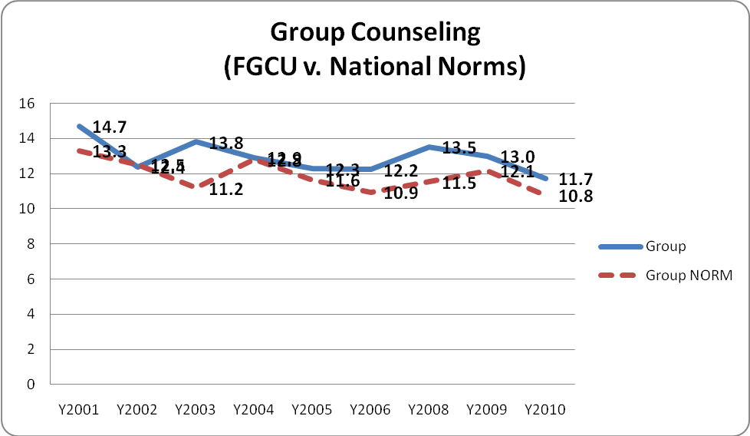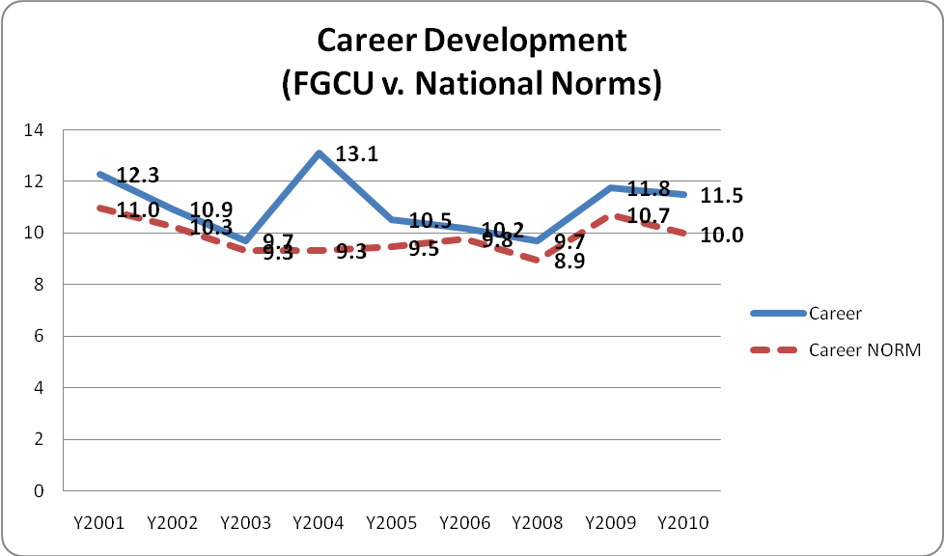
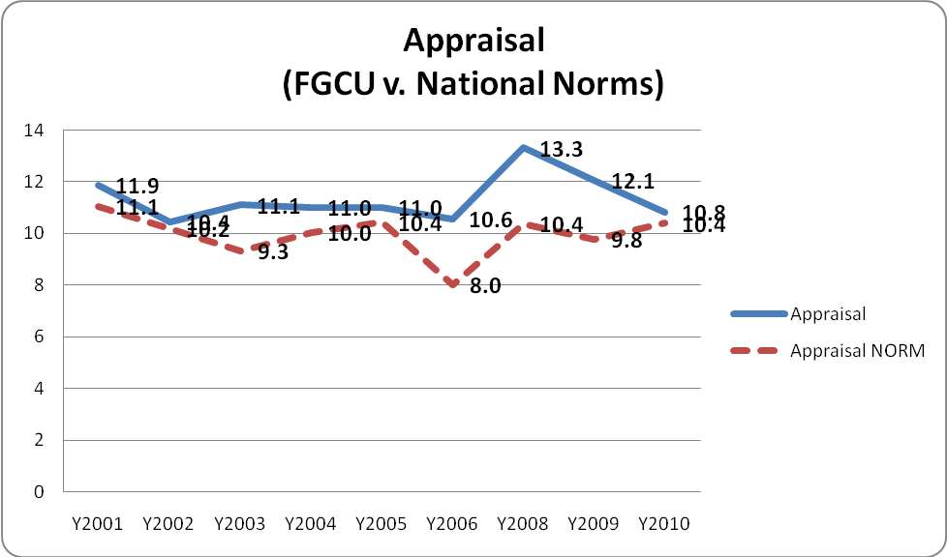

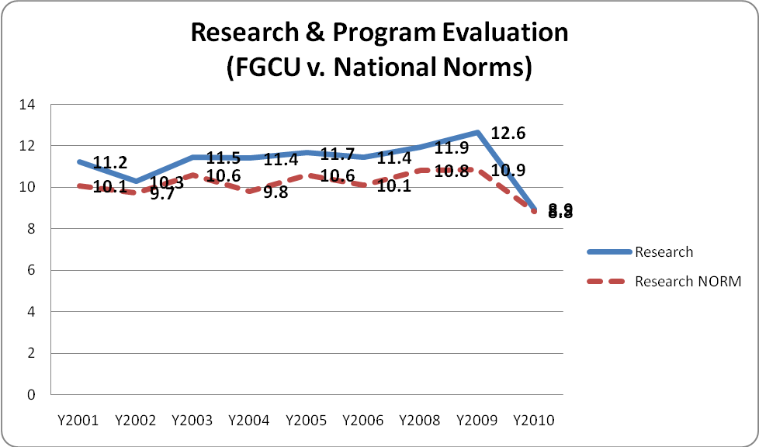
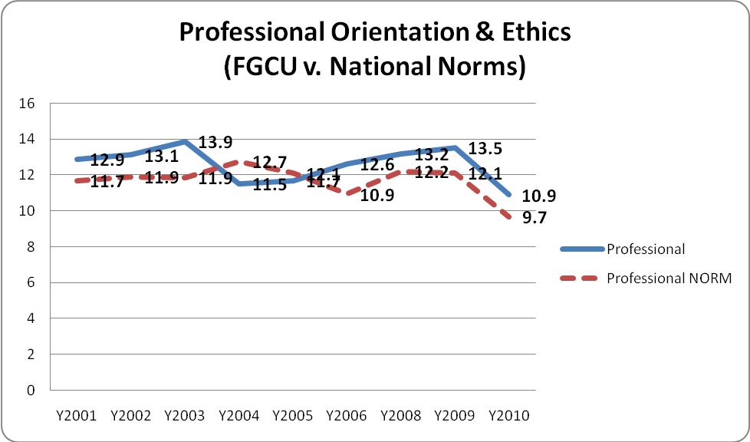

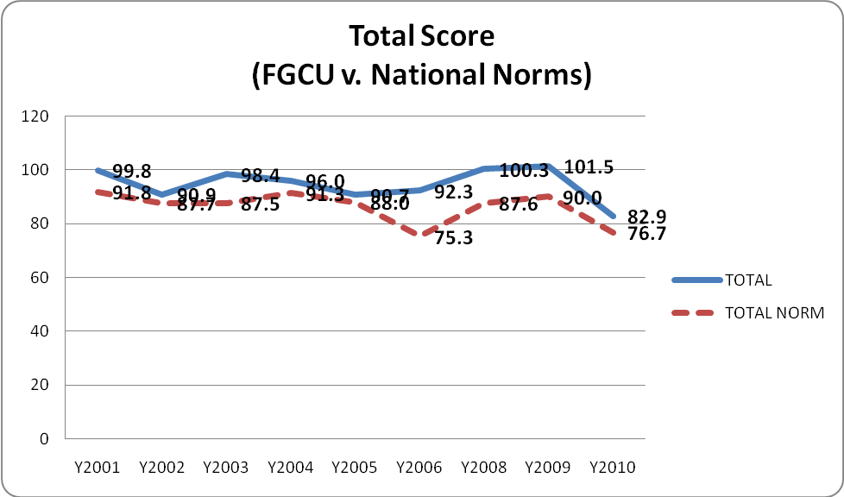
Program Improvements Made in 2008

What changes were made to foster improvement in the attainment of the specific outcome(s) in response to the analysis of results? Following are actions taken by the faculty to address improvement:

- Updated policy about passing scores on the CPCE. Faculty updated policy about passing scores on the CPCE exam to reflect changes in national norms. The new policy states that: Students must obtain a minimum score of 90 and 95 for first and subsequent administrations, respectively, unless the norms are significantly different (skewed) on the national level. (Meeting minutes, September 4, 2008)

- Updating the Career Development Course. FGCU Counseling faculty consulted with other institutions that use the exam and discovered that they too were experiencing similar lower means on the Career Development subscore (which was also reflected in the national norms). Also, faculty solicited feedback from our students who reported that the section on Career contained questions mostly concerning theory. The FGCU Counseling program Career Counseling course focuses on both the Career Development/Counseling theory and the practical approaches to doing Career activities. Finally, faculty consulted with school district Student Service Department Directors to include more competencies consistent with area needs. As a result, the course was updated to include more on Counseling theory and career counseling tools/software.

- More structured study and review. After conducing informal interviews with students, we determined that there seemed to be a significant positive correlation between how much students report that they studied and their exam results. Thus, the faculty included more structured time for review as a part of the Seminar and Internship courses and also as an opportunity coordinated by the FGCU Counseling Honorary, Chi Sigma Iota. Also, our website was updated with resources and strategies for preparing for the CPCE (see http://coe.fgcu.edu/mentalhealthma/exitexam.html).

- Updates to the Appraisal and Human Development Courses

Since 2008, students in the Appraisal course now have access to more up-to-date appraisal instruments to practice administration, interpretation, and reporting.

Students in the Lifespan Development course are required to observe a child in a natural setting, compare and contrast what they have observed with the information from the text and course lectures, write and present a research paper, and take weekly quizzes. The rationale includes the following:

- This allows students to better distinguish between developmentally normal behavior and abnormal behavior;
- Increases essential observation skills;
- Requires students to develop advanced evaluation skills during observations.

In addition to the observation, students in the Lifespan Development course now conduct a review of the lifespan development literature, write a paper, create a tri-fold visual aid, and create a handout summarizing the findings of their research which they also present in class.

How do we know the changes were effective?

Tracking improvements made in 2008 suggest that they were working. That is, changes to course and instructional design were made to strengthen student learning and to better align our teaching with the standards were implemented in each of Career Development, Lifespan Development, Appraisal, and Research and Program Evaluation. Such changes included variously making resources more continuously available to students, increasing coverage of targeted areas in the curriculum, increasing assessment of student learning in targeted areas and monitoring student performance in the courses where these areas are largely taught. Note that the impact of these changes depend on place in the course sequence of each of these courses (Human) Lifespan Development is largely a first year course and thus students will not show the impact of changes for two years while the others are second year courses and thus show the impact of changes more immediately.

Continuous Improvement: Using the information from the last two years to redirect our efforts

Several factors could be responsible for the marked change in performance for 2010’s administration. The program experienced an instructional disruption during the fall of 2009 which impacted especially the career development area. While a new course design was implemented in the fall of 2008 which results showed in 2009, the course reverted to prior design in the fall of 2009 and then had an instructional change two-thirds of the way through that term. For that area, the course has been restored during the fall of 2010 to its 2008 format and results will be reviewed for the fall 2011 administration of the exam to monitor if improvements will continue.

(Human) Lifespan Development had shown gains in the 2008 and 2009 administrations but fell closer to the national norm in 2010. The program will review the curriculum with faculty to determine whether this was a one-time event or if more changes need to be accomplished in the future. Furthermore, instructional changes and separating the sections by program (School and mental Health) were implemented due to burgeoning program enrollments in the fall of 2010. The impact of these changes can be reviewed in the Fall of 2011.

Appraisal demonstrated sharp gains in 2008 and 2009 over prior years reflecting improvements made to the course. While it remained higher than national norms in 2010, the difference was reduced and this area will also be monitored to identify performance in 2011 to determine if there is an anomaly. As well, a faculty change for Spring 2011 for that course may impact performance that can be reviewed for impact in the Fall of 2011.

Like the other areas of focus, Research and Program Evaluation had seen gains in 2008 and 2009 which resulted from a strong focus on developing the counseling research and evaluation course. However, a change in direction and faculty in 2010 may be responsible for the decline in the score and to the national mean. Changes will be implemented by the new faculty teaching that course to more directly address curricular areas of deficiency when taught in 2011. These improvements will be monitored in the Spring of 2011.

A review of the results trends over the last two years, and in comparison to national norms, suggest that we may wish to redirect our focus for improvements. Areas where performance has seen a drop include Social and Cultural Foundations, Appraisal, Research and Program Evaluation.

Additionally, Human Development changes were complicated by personnel changes this year and splitting sections due to enrollment growth. When these students enroll for the exam in the Fall of 2011 we will have the opportunity to assess the impact of splitting the sections and different instructors teaching courses.

Both Social and Cultural Foundations and Research and Program Evaluation had new designs that were necessitated by a change in instruction. The former course was combined between the two programs and it was determined that the cross-listing of that course is not effectively covering the curricular needs of both groups. The school counseling students who took the test this past fall were a small group who had been “tacked on” to a cross-listed section of cross-cultural counseling with a faculty member who is no longer teaching. It is possible that in trying to meet the curriculum needs of this combined group that neither group was well served. In Spring 2010, the Social and Cultural Foundations course was split and redesigned with new instruction. The school counseling students who took the exam in the Fall of 2010 were exposed to the separate course with part-time instructors. The Mental Health Counseling students who took the course with a new full-time instructor have not yet taken the exit exam so the impact of that course design remains to be seen. An analysis of the mean by program since this course was split and the students had different instruction experiences reveal that the school counseling group had a mean of 7.667 while the Mental Health group had a mean of 8.56 thus changing the spread around the mean. In the Spring of 2011, this course is being taught by a part-time instructor from out of the area and has been moved to be entirely on-line. The results of this second part-time instruction of this course will be monitored for effectiveness in the fall of 201’s administration.

Research and Program Evaluation has already been reconceived by its new instructor to take into account the need to more closely align the course with CACREP standards. This change will be implemented in the Summer of 2011 and can be assessed with the Fall 2011 exit exam administration.

Other Updates to the Program in 2008

Because of feedback from students, from our advisory council meetings, and from internship site supervisors, other changes in the program have also been made:

- Community members let us know that they though it helpful for our students to have training in Mental Disorders (and diagnosis) earlier in the program. We agreed and moved this course in the sequence.

- The faculty added a reading literacy course as part of the school counseling plan I program per new Florida Department of Education requirements.

- FGCU counseling program faculty updated the Research and Program Evaluation course to include more knowledge and skills in the latter (program evaluation). This update was in response to best practice and the professional literature (e.g., ASCA National Model: A Framework for School Counseling Programs, 2006).

- Also in response to the professional literature and best practice, the “Closing the Gap Results Report” assignments in School Counseling Internship 2 and 3 were updated to include a rationale for interventions chosen. That is, students provide an evidence based explanation of the interventions they chose.

Updates to the Program in 2010

In the Fall of 2010 the program was operating with three faculty (one visiting instructor whose line is planned to be replaced by a full-time faculty member after a search in the Spring of 2011. As well, enrollments in the programs are burgeoning with more than 40 entering Mental Health Students and 25 School Counseling students. These translate to more than 120 students currently enrolled in the Counseling Program. During the last CACREP accreditation review, there were 60 FTE students and 5 FTE core faculty. Self-study for reaccreditation of the program begins in fall 2011 and will be subjected to CACREP’s revised, 2009 standards. Currently the program has 80-90 FTE students with 3.25 FTE faculty.

CACREP standards require a ratio of 1:10 FTE faculty to students, require that full-time Core Faculty outnumber part-time faculty and specify a host of requirements for field experiences. As our class sizes grow, field experience needs expand, the ability of Core Faculty to teach, supervise, and manage or monitor part-time faculty diminishes. There is a possibility of reduction in quality that may show on our exit assessments. It is thus strongly recommended that future monitoring of program performance on the exit exam account for class sizes and differences between those sections taught by full-time and part-time faculty.

