**Appendix IA**  
FGCU Catalog Descriptions

<http://www.fgcu.edu/Catalog/index.asp>

Accreditation information:

<http://www.fgcu.edu/Provost/accreditation.html>

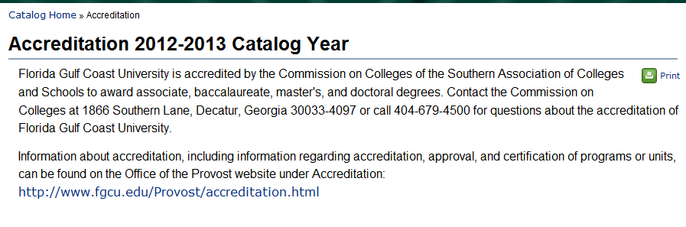FGCU Mission, Vision, and Guiding Principles  
<http://www.fgcu.edu/info/mission.asp>

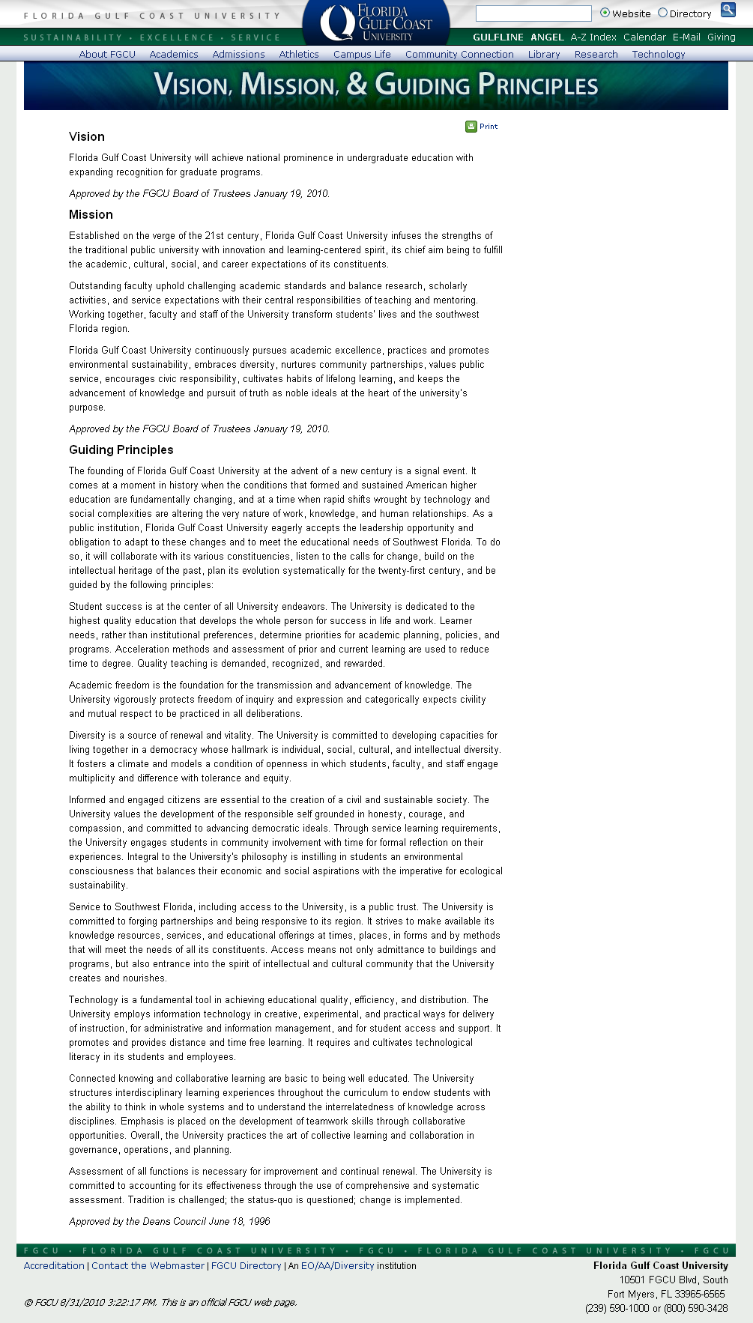

Historical Perspective  
<http://www.fgcu.edu/info/HistoricalPerspective.asp>

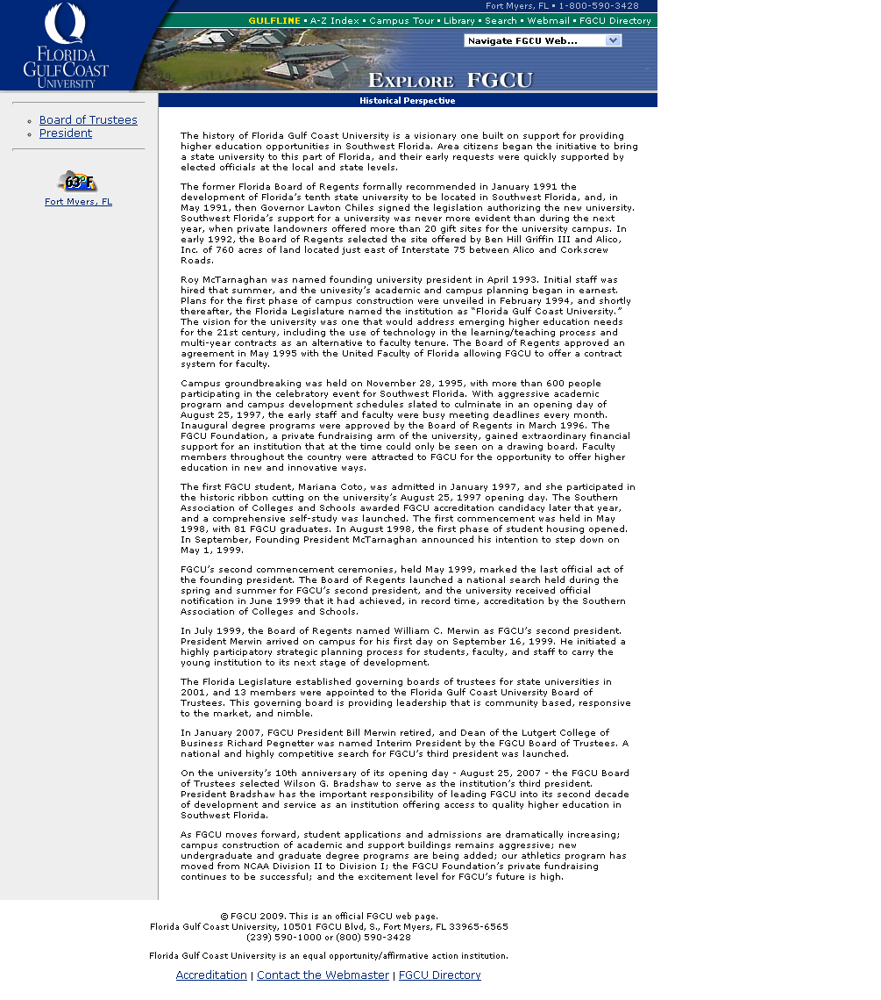

FGCU Accreditation  
<http://www.fgcu.edu/Provost/accreditation.html>

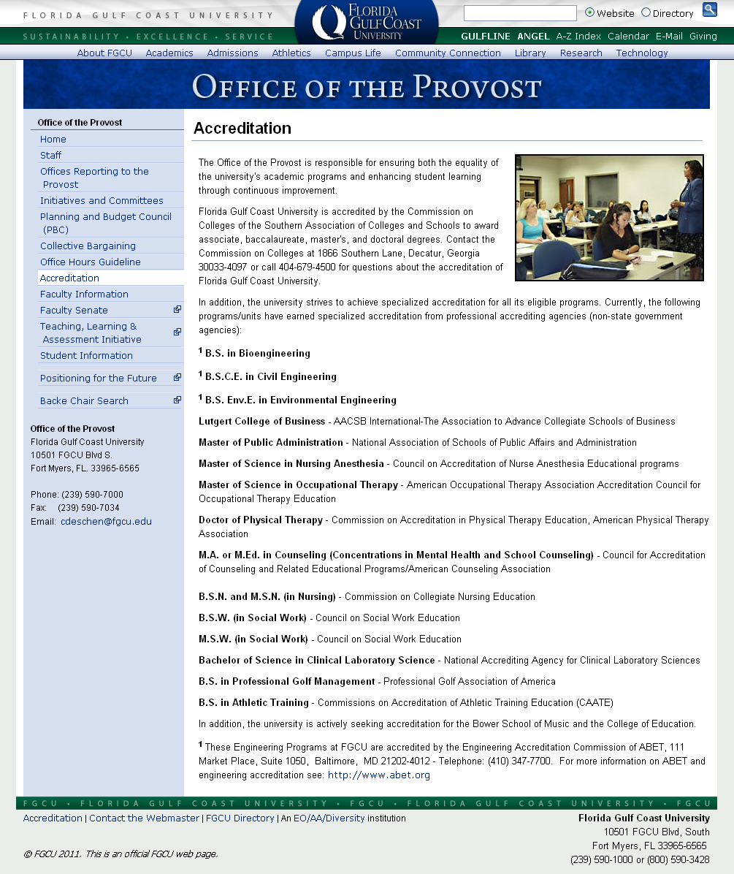



**Colleges and Schools**

**2011-2012 Catalog Year**

**College of Arts and Sciences**

**AB7 4th Floor Deans Suite**[**http://www.fgcu.edu/cas/**](http://www.fgcu.edu/cas/)  
**(239) 590-7205**

**Dean:** Donna Henry, Ph.D.  
**Associate Dean:** Debra Hess, Ph.D.  
**Associate Dean:** Jim Wohlpart, Ph.D.  
**Academic Advisors:** Allison Bacigalupi M.Ed.; Laura Brazzeal, M.Ed.; Lucero Carvajal M.P.A.; Jennifer Littell, M.A.; Melanie Stanis, M.A.; Mary Swanson  
**Administrative Assistant:** Dewie Robinson (239) 590-7155  
**Executive Secretary for Advising:** Patricia Rice, M.A. (239) 590-7196

**Mission Statement**

The College of Arts and Sciences (CAS) at Florida Gulf Coast University is dedicated to providing a quality liberal arts education that is the foundation for a free and just society. As a community of scholars, we seek to foster intellectual breadth and depth, reasoned and civil inquiry, intercultural understanding, an ecological perspective, and civic engagement in order to prepare students for a life in the 21st century that is at once informed, examined, and engaged. We support scholarly activity that advances teaching and contributes to the broader intellectual, artistic, and professional communities. Our college faculty and administration share the belief that interdisciplinary collaboration and scholarship enhance our individual disciplines and benefit our students. We further acknowledge that service to the southwest Florida community is a public trust and a social responsibility. In all of our activities, we are committed to celebrating and nurturing human freedom and elevating the human spirit.

Founded on the university’s student learning goals and emphasizing the integration of knowledge across disciplines, our programs in the arts, humanities, natural sciences, and social sciences offer students the opportunity to develop the knowledge, skills, and values necessary for success in their professional careers along with the philosophical, scientific, and artistic habits of mind indispensable for a democratic society and a rewarding personal life. We challenge students to express informed convictions, exercise independent judgment, and make a lifelong commitment to learning. By encouraging tolerance, generosity, humility, wisdom, creativity, and courage, we strive to prepare students for a rapidly changing world, constructive engagement with diverse cultures and beliefs, responsible participation in their communities, and a deeper appreciation of the beauty and scope of human experience.

Scholarly activity provides a source for the creation and communication of artistic insights, fresh ideas, and current information related to our teaching, our individual disciplines, and to the integration of knowledge that lies at the heart of our liberal arts mission. Through scholarship, we interact with colleagues in the academic community and in the southwest Florida region. Likewise, in our service, we expand the boundaries of the university and join a wider community in nurturing a sustainable and enriched society.

**Admission to Graduate Programs**

Application deadlines for CAS graduate programs are listed on the FGCU Graduate Studies website. Prior to admission to a graduate program, students may complete a maximum of nine credit hours of graduate level courses on a non-degree-seeking basis. Minimum admission requirements for each degree program are listed under that program’s heading.

**Graduate Advising**

Following admission to the program, students work with the Graduate Studies Coordinator in their program to determine their course of study.

**Bower School of Music**

<http://www.fgcu.edu/CAS/BSM/index.html>

Music Education & Performance Building

**Degree: Music (B.A.)**

**Concentrations:** Music Education; Music Performance **Minor:** Music

**Department of Biological Sciences**

<http://www.fgcu.edu/CAS/Departments/BS/index.html>

Whitaker Hall 234

**Degree Programs:** Biology (B.A. and B.S.); Biology-Accelerated (B.S.); Biotechnology (B.S.)

**Department of Chemistry and Mathematics**

<http://www.fgcu.edu/CAS/Departments/CM/index.html>

AB7 208

**Degree Programs:** Chemistry (B.A.); Mathematics (B.A., B.S., and M.S.) **Minors:** Chemistry; Mathematics

**Department of Communication and Philosophy**

<http://www.fgcu.edu/CAS/Departments/CP/index.html>

Reed Hall 231A

**Degree Programs:** Communication (B.A.); Journalism (B.A.); Philosophy (B.A.) **Minor:** Critical Theory; Interdisciplinary Studies; Journalism; Philosophy; Religious Studies

**Department of Language and Literature**

<http://www.fgcu.edu/CAS/Departments/LL/index.html>

Reed Hall 108B

**Degree Programs:** English (B.A. and M.A.) **Minors:** Creative Writing; English; Spanish

**Department of Marine and Ecological Sciences**

<http://www.fgcu.edu/CAS/Departments/MES/index.html>

AB7 443

**Degree Programs:** Anthropology (B.A.); Environmental Studies (B.A. and M.A.); Environmental Science (M.S.); Marine Science ( B.S.) **Minors:** Anthropology; Earth; Space Science

**Department of Social and Behavioral Sciences**

<http://www.fgcu.edu/CAS/Departments/SBS/index.html>

Modular 1, Lobby

**Degree Programs:** History (B.A. and M.A.); Psychology (B.A.); Sociology (B.A.) **Minors:** African and Diaspora Studies; Community Planning and Development; Gender Studies; Global Studies; History; Psychology; Sociology; Southwest Florida Studies

**Department of Visual and Performing Arts**

<http://www.fgcu.edu/CAS/Departments/VPA/index.html>

Arts Complex 107

**Degree Programs:** Art (B.A.); Theatre (B.A.) **Minors:** Art; Theatre

**College of Education**

**Academic Building 3**[**http://coe.fgcu.edu/**](http://coe.fgcu.edu/)  
**(239) 590-7800**

**Vision**

We envision our graduates, and those they influence, as the learners and leaders of today and tomorrow. As learners, our graduates will continue to grow and develop as leaders within their field. As leaders, they will build upon the diverse backgrounds and perspectives they encounter to ensure that all individuals are able to construct the understanding necessary to become successful.

**Mission**

Our mission is to provide diverse environments of excellence that support dynamic learning experiences. In these environments, faculty and students reflect upon and engage in the applications of theory, research, and emerging technologies. These environments support the construction of knowledge, skills, and attitudes through collaboration and inquiry. As a result, faculty and students are empowered to create an enhanced quality of life within their respective communities.

**Teaching Certification/Counseling Licensure/Endorsement**

The College of Education (COE) offers courses and/or sequences of courses that can be used toward initial certification or endorsements by the Department of Education in a variety of teaching specialty areas and licensing by the Department of Health in Mental Health Counseling. The process of seeking and obtaining certification or licensing is separate from enrolling in COE courses or obtaining a degree. Students who have arrest or conviction records may be ineligible for certification or licensure in the State of Florida. Most certification and licensure requirements include passing state administered competency exams. Contact the COE advising office for additional information regarding exams. Contact appropriate state or school district personnel regarding certification and licensure procedures.

**Technology Statement**

The philosophy of the COE is that technology is one of numerous means of facilitating the educational process within the college and within the educational communities our programs serve. Technological proficiency is expected as a prerequisite skill, similar to the expectation that all learners can write, use appropriate grammar, access library resources, etc. The university provides a variety of opportunities for increasing technological proficiency, including courses, self-study guides, short courses, workshops, and tutoring. Students who do not own or have access to an adequate home computer system will be expected to utilize on-campus computing resources to complete many course requirements. Technology is an essential and integral aspect of each course, and some courses may have software requirements beyond those found on an average home computer.

**Admission to a Master’s Programs**

If the number of qualified applicants to a program exceeds the capacity, preference will be given to students who, after review of the entire graduate application, demonstrate the strongest potential for success in the chosen field. Students who have not achieved minimum test scores or the minimum GPA but who meet all other requirements may, under special circumstances, petition the department to be considered for admission into a program.

**Graduate Advising**

(239) 590-7797

Degree-seeking students in graduate programs are advised by program faculty. Master degree students are assigned advisors upon admission to programs. Educational Specialist students are assigned an advising committee. Once admitted, all graduate students are oriented by faculty in their individual programs. Students complete a plan of study with an advisor or committee during the first semester of enrollment after admission to the degree program.

**Transfer of Graduate Coursework**

The College of Education limits the transfer of coursework into its graduate programs to a maximum of 12 credits or three courses. To be considered, courses must have been completed with a minimum grade of B and no more than seven years prior to the date of entry into the graduate program and no more than ten years prior to graduation from the graduate program. Decisions concerning the transfer of coursework are made at the time of admission. Transferred courses will be noted on an approved plan of study.

**Undergraduate Studies**

**Degree Programs:** [Early Childhood Education](http://coe.fgcu.edu/earlychildba/index.asp) (B.A.), [Elementary Education](http://coe.fgcu.edu/elemedba/index.asp) (B.A.), [Secondary Biology Education](http://coe.fgcu.edu/secbioedba/index.asp) (B.A.), [Secondary Mathematics Education](http://coe.fgcu.edu/secmathedba/index.asp) (B.A.), [Secondary Social Science Education](http://coe.fgcu.edu/secssedba/index.asp)(B.A.), [Special Education](http://coe.fgcu.edu/specialedba/326.asp) (B.A.), and Child and Youth Studies (B.S.) **Minor:** Education

**Graduate Studies**

**Degree Programs:** Counseling (M.A. or M.Ed.); [Curriculum and Instruction](http://coe.fgcu.edu/c-imed/index.asp) (M.Ed.); Curriculum and Instruction: [Educational Technology](http://coe.fgcu.edu/c-iedtechma/index.asp) (M.A. or [M.Ed.](http://coe.fgcu.edu/c-iedtechmed/index.asp)); [Educational Leadership](http://coe.fgcu.edu/edleadershipmed/index.asp) (M.A. or M.Ed.);[Elementary Education](http://coe.fgcu.edu/elemedmed/index.asp) (M.Ed.); [Reading](http://coe.fgcu.edu/readingmed/index.asp) (M.Ed.); and [Special Education](http://coe.fgcu.edu/specialedmed/index.asp) (M.Ed.); [Educational Specialist](http://coe.fgcu.edu/educationeds/index.asp) (Ed.S.); Doctorate in Education (Ed.D.)

The [Educational Specialist (Ed.S.)](http://coe.fgcu.edu/educationeds/index.asp)

The Doctorate in Education (Ed.D

The [Teacher Immersion Program (TIP)](http://coe.fgcu.edu/TIP-rd.html) is a Florida Gulf Coast University partnership program with area school districts that supports individuals who have a bachelor's degree and an interest in teaching careers.

**College of Health Professions**

**Griffin Hall 135**[**http://chp.fgcu.edu**](http://chp.fgcu.edu/)  
**(239) 590-7450**

**Dean:**Mitchell L. Cordova, PhD  
**Associate Dean:**Joan Glacken, EdD, & Chair, Health Sciences  
**Interim Director, School of Nursing:** Anne Nolan, PhD  
**Chair, Physical Therapy & Human Performance:** Sharon Bevins, PhD  
**Chair, Occupational Therapy and Community Health:** Linda Martin, PhD  
**Assistant Professor, Physical Therapy:** Thomas Bevins, MS  
**Professor:** Halcyon St. Hill, EdD  
**Academic Advisor (School of Health & Rehabilitation):** Lorie Hickox, BS  
**Academic Advisor (School of Health & Rehabilitation):**Maxine Faatz, BS  
**Academic Advisor (School of Nursing):** Anne Young, MA  
**Administrative Assistant:** Lynn O’Hare

**Vision**

The College of Health Professions promotes wellness, quality health care, and healthy environments through excellence in education, research, service, and community partnerships.

**Mission**

The College of Health Professions provides students with health professions education that is grounded in academic excellence, fosters critical thinking and ethical practice, and promotes interdisciplinary collaboration. Faculty in baccalaureate and graduate educational programs facilitate development of active learning, emphasize evidence based practice, utilize multiple delivery systems, develop inter-professional relationships, and cooperate with community partners to prepare competent and caring health professionals.

**Goals**

The College of Health Professions goals are to:

* Prepare students to assume vital roles as health professionals delivering care in diverse and dynamic interdisciplinary and global environments.
* Promote professional behaviors including ethical practice, competent and compassionate care, cultural competence, and effective communication skills.
* Facilitate critical thinking, evidence-based practice, and a commitment to life-long learning.
* Support faculty and student participation in scholarly activities.
* Promote active involvement of faculty and students in providing service to local and global communities.
* Foster career advancement and engagement in lifelong learning among healthcare personnel in the communities we serve.

**School of Health & Rehabilitation**

**Division of Health Sciences**

**Degrees:** Clinical Laboratory Science (B.S.), Health Science (B.S.), and Health Science (M.S.) **Certificates:** Clinical Laboratory Science and Health Services Administration

**Department of Occupational Therapy and Community Health**

**Degrees:** Community Health (B.S.), and Occupational Therapy (M.S.)

**Program Accreditation**

The Occupational Therapy program is accredited by the Accreditation Council for Occupational Therapy Education (ACOTE) of the American Occupational Therapy Association (AOTA), located at 4720 Montgomery Lane, P.O. Box 31220, Bethesda, Maryland, 20824-1220, Telephone: (301) 652-2682.

**Department of Physical Therapy and Human Performance**

**Degrees:** Athletic Training (B.S.), Human Performance (B.S.), and Physical Therapy (D.P.T.)

The Doctor of Physical Therapy program has been granted accreditation status by the Commission on Accreditation in Physical Therapy Education of the American Physical Therapy Association.

**School of Nursing**

**Degrees:** Nursing (B.S.N.), Nursing (M.S.N.) **Certificates:** Primary Health Care Nurse Practitioner

The baccalaureate nursing program (BSN) is approved by the Florida Board of Nursing (4052 Bald Cypress Way, Bin #CO2, Tallahassee, FL  32399-3257, telephone number 850-488-0505) and accredited by the Commission on Collegiate Nursing Education (CCNE) (One Dupont Circle, NW, Washington, DC  20036-1120, telephone number 202-887-6792).

The Master of Science in Nursing (MSN) program is accredited by the Commission on Collegiate Nursing Education (CCNE) (One Dupont Circle, NW, Washington, DC 20036-1120; telephone number 202-887-6791).

The Nurse Anesthesia program is accredited by the Council on Accreditation of Nurse Anesthesia Programs (COA), 222 S. Prospect Avenue, Suite 304, Park Ridge, IL 60068-4010, (847) 692-7050.

**College of Professional Studies**

**(NOTE: CPS WAS DISSOLVED AT THE END OF 2012 AND ITS PROGRAMS ABSORBED BY THE COLLEGES OF ARTS AND SCIENCES, BUSINESS AND HEALTH PROFESSIONS; CATALOG DESCRIPTIONS WERE NOT AVAILABLE AT THE TIME OF THIS SELF-STUDY.)**

**Academic Building 3  
Sugden Hall**[**http://cps.fgcu.edu/**](http://cps.fgcu.edu/)  
**(239) 590-7820**

**Interim Dean:** Tony A. Barringer, EdD

**Vision**

The College of Professional Studies at Florida Gulf Coast University offers baccalaureate and graduate degree programs in specialized career and professional fields. The college also offers programs and projects that meet the lifelong professional development needs of practitioners. The faculty recognizes the changing climate in the professional disciplines, where learning must be linked to community and regional needs, and recognize diversity in culture and environment.

**Mission**

The College of Professional Studies is committed to educating professionals in the public-, private-, and not-for-profit sectors, as well as to developing students’ problem-solving abilities in the realms of government, law, leisure, and social services. Recognizing the rapidly changing environments in which such efforts must be carried out, the College’s curricula are oriented toward lifelong approaches to professional and personal development integrating theory, practice, technology, and diversity. All programs in the College link students’ learning experiences to the needs of communities and their members.

**Goals**

* Prepare students to respond in innovative ways to the evolving social, political, economic, and natural environments in which policy-making and service delivery are carried out.
* Cultivate an ethic of public integrity and civic engagement in professional, political, and community activities.
* Develop an understanding of the multi-cultural and increasingly global contexts within which public problems emerge, as well as an ability to formulate interdisciplinary strategies for their identification and resolution.
* Cultivate the knowledge, skills, and personal attributes required for life-long growth and development.
* Integrate multiple, state-of-the-art technologies into the learning environment and develop students’ abilities to use technology creatively in their work.
* Develop comprehensive field-based experiences linked to individual and community development.

**Divisions and Programs**

The College of Professional Studies houses four divisions offering seven undergraduate majors, one undergraduate minor, four master's degrees, and one graduate certificate, including:

* Justice Studies
  + Forensics Studies (B.S.)
  + Forensics Studies (M.S.)
  + Criminal Justice (B.S.)
  + Criminal Justice (M.S.)
  + Legal Studies (B.S.)
  + Compliance Specialist Graduate Certificate
* Public Affairs
  + Master of Public Administration (MPA)
  + Political Science (B.A.)
  + Political Science Minor
* Resort & Hospitality Management
  + Resort and Hospitality Management (B.S.)
  + PGA Golf Management (B.S.)
* Social Work
  + Bachelor of Social Work (BSW)
  + Master of Social Work (MSW)

See the College website for more information on our academic programs ([http://cps.fgcu.edu](http://cps.fgcu.edu/))

**Lutgert College of Business**

**Lutgert Hall  
(239) 590-7302**  
[**http://www.fgcu.edu/cob/**](http://www.fgcu.edu/cob/)

[**Dean's Office**](http://www.fgcu.edu/CoB/deansstaff.html)

[**Faculty and Staff Directory**](http://www.fgcu.edu/CoB/directory.html)

The Lutgert College of Business (LCOB) is named in honor of Raymond L. and Beverly Lutgert whose generous gift helped provide a state-of-the-art building to house the undergraduate and graduate business programs.

**Vision**

A faculty of outstanding teacher-scholars building a distinctive business learning community based on partnerships among students, faculty, businesses, and the southwest Florida region to prepare highly-skilled and capable leaders of tomorrow.

**Mission**

The Lutgert College of Business provides a high quality, student-centered learning environment to prepare students with the knowledge and skills needed to contribute to and take leading positions in business and society. Our faculty are devoted to teaching excellence, scholarship, and service that enhances our academic and business communities and we are dedicated to building partnerships that foster the economic growth of the southwest Florida region and beyond.

**Accreditation**

The Lutgert College of Business is accredited by AACSB International - The Association to Advance Collegiate Schools of Business.

**Core Values/ Guiding Principles**

The following principles and values give direction to the college's mission, and recognize that scholarship and service support the primary focus on teaching and learning.

**Diversity:** We foster a climate that enhances awareness of and respect for a diversity of people and ideas, actively encouraging it among our faculty, staff and students.

**Economic Development:** We address current regional business issues through extensive outreach activities and partnerships on a local, regional, and global basis to facilitate the economic vitality and branding of Southwest Florida.

**Environmental Sustainability:** We educate and develop future business professionals to recognize the value of and need for environmental sustainability as it relates to business practice and decision-making.

**Global perspective:** We emphasize the ability to perform effectively across cultures in addressing global business challenges and opportunities using the "second circle*" model.

**Integrity:** We maintain the highest standards of ethics, honesty, mutual respect, and accountability for our college's faculty, staff and students.

**Scholarship:** We strive to produce scholarship that is useful to students and business practitioners and that enhances the visibility and reputation of our college.

*The second circle model was created by founding Dean Dr. Richard Pegnetter as a process that expands the traditional college/university to international university partnership model to include the regional business community of Southwest Florida with the regional business community of our international university partner thus expanding the interaction to a "second circle".

**Department of Accounting**

[**Accounting Faculty Directory**](http://www.fgcu.edu/CoB/AccountingDept.html)

**Degrees:** Accounting (B.S.), Accounting and Taxation (M.S.)

**Department of Economics and Finance**

[**Economics and Finance Faculty Directory**](http://www.fgcu.edu/CoB/economicsfinancefaculty.html)

**Degrees:** Economics (B.S.) Finance (B.S.) **Minors:** Economics, Real Estate

**Department of Information Systems and Operations Management**

[**Information Systems and Operations Management Faculty Directory**](http://www.fgcu.edu/CoB/cisdept.html)

**Degrees:** Computer Information Systems (B.S.), Computer Information Systems (M.S.) **Minors:** Computer Information Systems, ISOM (Information Systems and Operations Management)

**Department of Management**

[**Management Faculty Directory**](http://www.fgcu.edu/CoB/Managementdept.html)

**Degrees:** Management (B.S.) **Minors:** Management

**Department of Marketing**

[**Marketing Faculty Directory**](http://www.fgcu.edu/CoB/marketingdept.html)

**Degrees:** Marketing (B.S.) **Minors:** Advertising, Marketing

**Undergraduate Programs**

[**B.S. in Accounting**](http://www.fgcu.edu/CoB/acgbs/index.asp)

[**B.S. in Computer Information Systems (CIS)**](http://www.fgcu.edu/CoB/cisbs/index.asp)

[**B.S. in Economics**](http://www.fgcu.edu/CoB/econbs/)

[**B.S. in Finance**](http://www.fgcu.edu/CoB/finbs/index.asp)

[**B.S. in Management**](http://www.fgcu.edu/CoB/mgmtbs/index.asp)

[**B.S. in Marketing**](http://www.fgcu.edu/CoB/mktbs/)

**Graduate Programs**

[**Master of Business Administration (M.B.A.)**](http://www.fgcu.edu/CoB/busmba/index.asp)

[**Executive M.B.A.**](http://www.fgcu.edu/CoB/bizemba/index.asp)

[**M.S. in Accounting and Taxation**](http://www.fgcu.edu/CoB/acgms/index.asp)

[**M.S. in Computer Information Systems (M.S. CIS)**](http://www.fgcu.edu/CoB/cisms/index.asp)

**U.A. Whitaker School of Engineering**

**The U.A. Whitaker School of Engineering was named in honor of Uncas A. Whitaker, founder of the AMP Corporation. A generous gift from The Whitaker Foundation, which was established in his honor, helped bring the Engineering School to life by providing the initial funding for Holmes Hall, a state-of-the-art building that houses the engineering and computer science programs. Holmes Hall was named in honor of Dr. G. Burtt Holmes and Dr. Ruth Whitaker Holmes in recognition of their many generous gifts to the University.**

**208 Holmes Hall**[**http://www.fgcu.edu/eng**](http://www.fgcu.edu/eng/)**(239) 590-7390**

[**Directors, Chairs, and Faculty**](http://www.fgcu.edu/eng/facultydirectory.html)

[**Vision and Mission**](http://www.fgcu.edu/eng/mission.html)

[**Director's Message**](http://www.fgcu.edu/eng/engdirector.html)

[**Academic Advising**](http://www.fgcu.edu/eng/engadvising.html)

[**Department of Bioengineering**](http://www.fgcu.edu/eng/BioDpt/index.html)

**Degree:** [Bioengineering (B.S.)](http://www.fgcu.edu/eng/BioDpt/biobs/index.asp) **Minor:** [Bioengineering](http://www.fgcu.edu/eng/bioengineeringminor.asp)

[**Department of Environmental and Civil Engineering**](http://www.fgcu.edu/eng/EnvCivDpt/index.html)

**Degrees:**

* [Civil Engineering (B.S.C.E.)](http://www.fgcu.edu/eng/EnvCivDpt/civbs/index.asp)
* [Environmental Engineering (B.S.Env.E.)](http://www.fgcu.edu/eng/EnvCivDpt/envbs/)

**Minor:** [Environmental Engineering](http://www.fgcu.edu/eng/environmentalminor.asp)

**Software Engineering Program**

**Degree:** [Software Engineering (B.S.)](http://www.fgcu.edu/eng/sebs/) **Minor:** [Computer Science](http://www.fgcu.edu/eng/computerscienceminor.asp)