|  |
| --- |
|  |
| Assessment Plan |
|  |
| Counseling Programs: Clinical Mental Health and School |

**college of education, Florida Gulf Coast University**

April 24, 2013

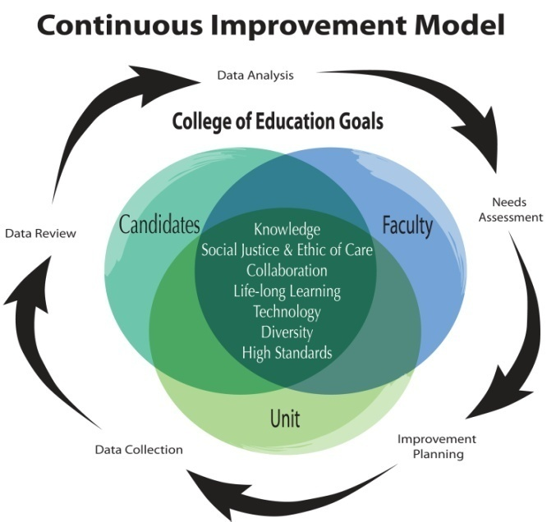

##### Continuous Improvement Model

The continuous improvement model implemented in the College of Education is highly efficient and effective. All phases of assessment for candidates, faculty, and unit operations occur in parallel, which provides for timely sharing of data necessary to evaluate successes, assess needs, and plan for improvements across the college. As the above graphic illustrates, the process is a continuous cycle in which all five phases are scheduled to occur annually. This facilitates the ability to make timely adjustments when needs are identified. The Counseling programs have modeled their assessment process after that for the College to create a more integrated approach that is also efficient to meet requirements specific to the program and inside the University.

The Counseling program faculty continually assess its course offerings and processes in order to incorporate the “best practices” as they pertain to the development and preparation of counselor candidates. As a result of thorough and active interaction with, and attention to, students, accrediting agencies, and state licensing boards, the Counseling programs at Florida Gulf Coast University (FGCU) consistently maintain its vibrancy and relevance in the dynamic field of counseling.

This continuous improvement model for the College of Education serves as a model or jumping off point for the Counseling programs. The Counseling programs use a mixed methods, multiple source of evaluation model to ensure that students are making adequate academic progress, learning content knowledge as targeted, demonstrating increasingly sophisticated skills, and engaging appropriately as emerging professionals. The aggregate performance of our students as well as other collected data serves to inform continuous program improvement.

**Counseling Programs:**

**Clinical Mental Health/ School**

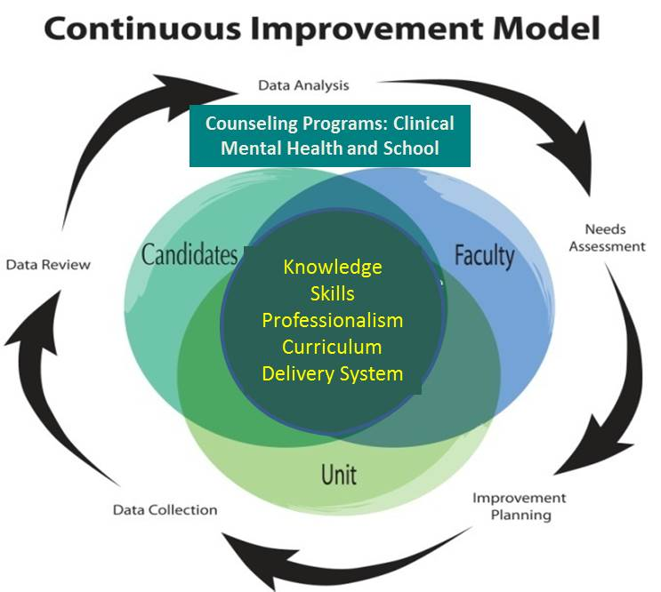

Since its inception, the Counseling programs have, and will continue to, respond to a dynamic and ever-changing world. There are hosts of ways in which we have attempted to be dynamic and responsive. Counseling programs faculty take their role of “gatekeeper” very seriously. We are aware that we are both ethically and legally responsible for our students as they work with often vulnerable human beings. In order to facilitate communication and provide timely, useful, thorough and meaningful feedback to trainees, program faculty conduct developmental, systematic assessments of each student in the program on a semester basis. These student review meetings are highly valued and beneficial; all faculty are present during these meetings.

Candidates are assessed extensively throughout their programs on specific indicators of competence, which include assessment of performance in relation to college proficiencies, program outcomes, state competencies (school counseling program for Florida’s Department of Education), and national standards (NCATE and CACREP.) Post-graduation surveys with candidates and their employers are also used to assess their professional preparedness, competence, and success in their fields.

Individual faculty engage appropriately in assessing student performance in their courses, integrate faculty scholarship in their everyday work and teaching, engage in program, college, university and community service, and work to improve teaching to meet needs in the program or fill gaps identified for improvement using aggregated data.

Reports are provided to the college and University administration and to stakeholders for accountability and to solicit feedback for –program improvement. Data are collected throughout the year and reviewed annually to assess achievement of college objectives. The aggregation, disaggregation, and analysis of these data facilitate college and university level strategic planning and evaluation.

Table 1 presents an overview of the timeline, purpose, and general activities that occur during each phase of assessment of candidates, faculty, and unit operations.

Table 1: Phases of the Continuous Improvement Model

|  |  |
| --- | --- |
| *Phase 1 – Data Analysis & Needs Assessment (August-September)* | |
| Candidate Proficiencies (Program Faculty) | Faculty Expectations (Individual Faculty and Supervisors, as applies) |
| Program review of previous year candidate and alumni data. Identify program needs. Results shared with faculty and administration. | Individual faculty review of previous year course assessments, program needs, and previous Annual Review of teaching, scholarship & service to develop and submit a new professional development plan. |
| *Phase 2 – Improvement Planning (September-October)* | |
| Program faculty develop and submit *Program Improvement Plans* to address candidate needs. Input from program advisory boards collected in the prior spring is included. |  |
| *Phase 3 – Implementation & Formative Assessment (September-April)* | |
| Implement program improvement plans and collect formative data on candidate progress. Prepare program revision documents for curriculum committee approval. | Implement professional development plan activities and collect data in areas of teaching, scholarship, and service. |
| *Phase 4 – Annual Review & Reporting (March-June)* | |
| Review formative data and develop the annual *Program Review Report* describing program accomplishments and submit to faculty, stakeholders, and administration. | Individual faculty review success in meeting objectives set forth in PDP. Develop an Annual Review involving a portfolio of accomplishments for submission to supervisor. |
| *Phase 5 – Data Aggregation & Statistical Analysis (On-going)* | |
| Aggregate, disaggregate, and analyze candidate performance data to respond to program improvement, accreditation, and annual reporting needs. |

#### Data collection, analysis, and evaluation

Through the continuous improvement process, comprehensive information on applicant qualifications, candidate proficiencies, student progress patterns (including retention and attrition), alumni competence, and faculty contributions to meeting program goals and standards, are collected, analyzed, and reviewed, at least annually.

##### Assessment of Candidates

Preparing candidates for their professions is the primary responsibility of program faculty and shared with site supervisors who host them during internships experiences. Thus, assessments of candidate outcomes are used by faculty and administration for the evaluation and improvement of programs, teaching, and program structure. Assessments of candidates occur at the time of admission, as they transition through their programs, each semester of registration (fall and spring), at the end of their programs, and through a variety of post-graduate periodic surveys. Multiple assessments are used in each phase of the continuous improvement cycle to obtain a comprehensive picture of candidate performance and program success.

Transition Points

The following Transition Point table depicts program requirements and assessments that are used to continually monitor and assess candidates as they enter, progress, and exit programs. These tables also depict specific check points that are used to ensure candidate readiness for subsequent stages of their programs, such as clinical experiences and program completion activities.

Counseling Programs Transition Point Assessments (Candidate Assessments)

|  |  |  |  |  |
| --- | --- | --- | --- | --- |
|  | | | | |
| Admission | Entry to Clinical Practice | Exit from Clinical Practice | Program Completion | After Program Completion |
| 1. 1000 GRE (or equivalent scale score) or 400 MAT 2. Or 3.0 GPA last 60 hrs 3. Bachelor’s degree from a regionally accredited university as indicated by all transcripts 4. Interview 5. Three positive letters of recommendation. 6. Essay explaining their professional goals for becoming a counselor. 7. School Counseling Only:    1. Met requirement for professional certificate or be prepared to enroll in required educator preparation courses.    2. Pass all sections of GKT | 1. GPA 2. B or better or S in courses: MHS 6700 (Legal and Ethical); MHS 6800 (Practicum,) & MHS 6800 (Adv. Prac.). 3. Standard assessments in each course in sequence. 4. Practicum Evaluations/ Assessments 5. Student Assessments by individual and total program faculty each semester. | 1. Internship observation assessments – counseling standards. 2. Completion of required direct and indirect contact hours under appropriate supervision. 3. School Counseling Only: Impact on student learning. | 1. GPA 2. Passing the CPCE exit exam. 3. B or better in all Program courses. 4. Completion of Program of Study 5. Demonstrate Competencies 6. Completion of all aggregate clinical experiences with a satisfactory grade. 7. School Counseling Only:    1. Passing score on guidance and Counseling FTCE Exam    2. Passing the Professional Educator Exam of the FTCE (if not already certified)    3. Demonstrate Florida Educator Accomplished Practices for School Counselors | 1. Graduate Follow-up Survey 2. Employer Survey 3. Advisory Bd. 4. School Counseling Only: Rehire Study |

The figure below indicates the flow of data that leads to assessing students as making adequate or inadequate progress each term toward graduation.

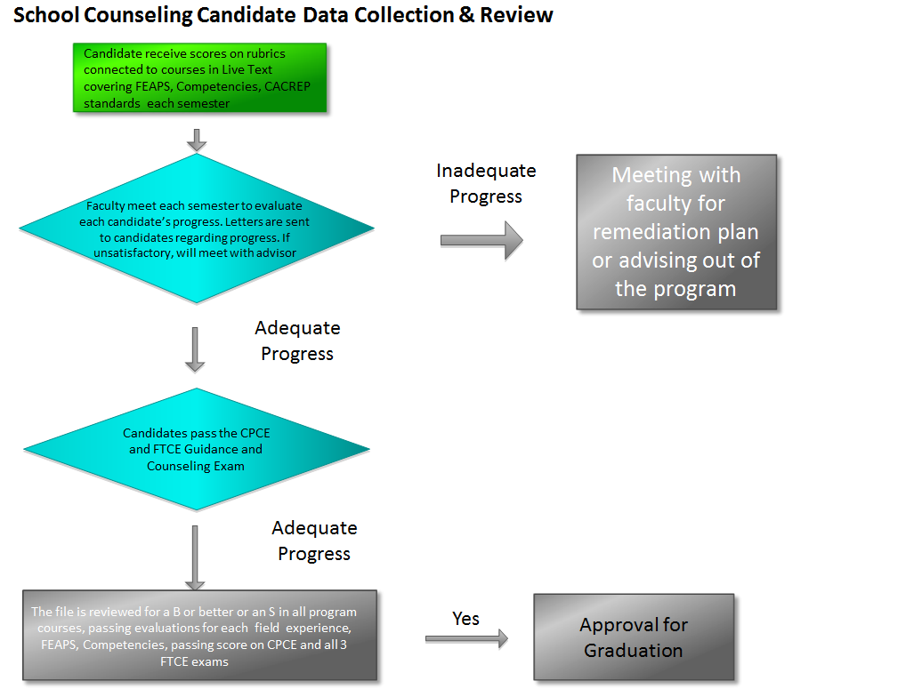

Applicant Admission Requirements and Data

As indicated above, the following data are used for admission purposes and are reviewed annually to assess its effectiveness in predicting candidate success and ensure fairness for all groups of applicants. The following data are used for admission purposes.

* GPA: The applicant’s Grade Point Average (GPA) from all prior degrees and coursework is used for admission decisions. Specifically, students must document a GPA of 3.0 in their undergraduate degrees OR have a master’s degree from a regionally accredited program. In lieu of GPA requirements, student may show promise as a mast4er’s student by providing a GRE of 1000 or MAT of 400 or score equivalent.
* Test Scores: Applicant entrance exam scores are required for admission. School counseling applicants who are not already certified teachers in Florida must show passing scores on the state General Knowledge Test for admission.
* Certification: The M. Ed. in School Counseling requires proof of teacher certification or certification eligibility for admission. Non-certificated teachers enter the MA program and complete additional courses and exams to qualify as certified school counselors.
* Recommendation: All candidates must submit three letters of recommendation on specific recommendation forms or letters.
* Interviews: All students are interviewed prior to admission.

Starting in 2012-13, a rubric has been developed which allows applicants to be rank ordered for admission to ensure that the necessary resources will be available as students make progress through the program. As well, based on a study of program attrition, it was determined that being more selective will increase program retention. This new rubric and improved review system will form the basis of a multiyear pilot study that attempts to develop more precision in weighting each element, more triangulation for ratings in individual and group interviews, and predictive corrections with academic and clinical performance.

Candidate Progress

All candidates in all programs are assessed regularly as they progress through courses, at specific transition points, and at the end of their programs. Candidates are expected to demonstrate competency on all proficiencies, program outcomes, state competencies (school counseling), and national standards.

As with most Counseling programs, program faculty can most readily assess academic and professional behaviors, although the individual student’s dispositions are typically most salient features of effective counselor ability. Students in need of extra support and/or a remediation plan are informed as soon as possible. The faculty reviews student performance every semester regarding academic progress, counseling skills, and professional and personal dispositions. The purpose of the student review meeting is to monitor academic and professional progress.

When necessary, the faculty meets with students to devise plans for remediation or intervention to accommodate differences in the ways that students meet program requirements. The student progress review may have a number of remedial steps to support student progress and retention in the program. There is a range of possible outcomes including conditional continuation in the program, delay of program completion, or termination from the program. In all cases, the faculty works with students to provide support during the transition process. The protocol is spelled out in the Graduate Student Manual and the FGCU catalog. Students are advised of these procedures during their orientation at the beginning of their program.

Students in need of a plan of development are directed to meet with program faculty (most often the student’s advisor and at least one other faculty member) in order to develop a plan for improvement. This process is designed to provide students with support and encouragement with the primary objective to assist students in being successful.

On a routine basis, in addition to student review meetings, a standing agenda item for counseling faculty meetings concerns any student issues that faculty bring forward. In this way, faculty can collaborate to provide early identification, remediation, and referral for students who are showing indications of academic or other problems that will affect performance and/or progress. The results of student review meetings as well as individual student issues that were raised during regular faculty meetings are documented in meeting minutes and through individual emails sent to students. Each email is filed individually with each student’s record.

Students with disabilities that impact learning performance are advised to follow the established university procedures published in the FGCU Student Catalog and course syllabi. As well, students who have language or other barriers to graduate school success are referred to the University’s Writing Center or other community resources to help improve their spoken and written language competencies.

Course-Based Assessments

* Critical Tasks: Each course has been identified to measure standards using a series of standards-based critical tasks that assess candidate progress towards meeting college, program, state, and national expectations and proficiency standards. Critical tasks are assessed with scoring rubrics that identify target, acceptable, and unacceptable levels of performance for the specific knowledge and skills. Stored in LiveText™ (an external education database), critical task rubrics contain key reference points or identifiers for the college proficiencies, program outcomes, state competencies, and national standards. These course-based formative assessments are administered in a variety of forms, such as projects (often requiring advanced technology such as web-based communication projects); planning and assessment projects; professional literature reviews; reflective journals; program design, quizzes and exams, case study analyses, and counseling demonstration projects, to name a few.
* Field Experiences: Each program has multiple course-based field experiences that allow for assessment of candidates’ ability to apply foundational skills and knowledge. These field experiences are monitored to ensure that candidates have experiences in diverse settings. Field experience assessments are considered critical tasks and are assessed using rubrics as described above.
* End-of-Course Evaluations: All students must demonstrate proficiency in the accumulation of field experiences and the exit exam which is the CPCE, a nationally developed and normed exit exam for counseling programs based on the eight CACREP core standards for counseling programs. Additionally, school counselors demonstrate proficiency on state competencies (called the FEAPs) and by passing all sections of the state certification exam prior to graduation.

NOTE: During the last year, the CACREP 2009 standards have been uploaded making the benchmark assignments from each course have been coded so that critical tasks may be more readily assessed for both a program and student evaluation. Faculty have been entering data in LiveText for the last three years at the end of each term and have reviewed the data reports annually. With the linkage to the 2009 CACREP standards, and the 2010 Florida Educator Accomplished Practices, and Counselor Guidance and Counseling Competencies, LiveText data will become more relevant and useful for program and student review.

Personal Improvement Plans

Both Counseling programs have provisions for an improvement or remediation process for students who have shown problems in meeting competency-based assessments or who demonstrate questionable attitudes, or behaviors that would not be consistent with counseling professionals. These are sometimes identified and addressed by individual faculty or rise to the surface during semester, student reviews. Students will be referred to at least one faculty member, often two, who can help the student understand what is being observed, how it might be problematic, and devise plans for remediation.

Clinical Experience Readiness

Prior to each successive field experience and as part of each semester’s review, readiness for clinical experiences. Candidates must submit an application to the Clinical Coordinator who works to identify potential sites as well as represent student readiness to the program faculty.

Program Culmination Assessments

The culminating experience for counseling programs is the CPCE. Additionally, School counseling students demonstrate meeting FEAPs during their field experiences and must pass all sections of the FTCE.

Exit Data Summary (Aggregated through 2011-12 data)

* Clinical Assessments = 100% of program graduates passed all field experience assessments.
* CPCE – all program graduates demonstrated proficiency at the 60%ile level on the national norms.
* Certification Exams: = 100% of school counseling candidates who graduate from a COE Initial Certification Programs passed state certification exams prior to graduation.
* Based on Follow-up data and anecdotal reports, 100% of the students who have taken a state licensure exam for LMHC or LPC (if they have left Florida) have passed it.

##### Alumni Follow-up

* Alumni Follow-Up Surveys: Following their graduation (or just prior to their exit), candidates are asked to complete an anonymous annual survey that documents perceptions of their preparation for job performance requirements aligned to college proficiencies and program outcomes.
* Employer Surveys: Periodically, alumni are provided questionnaires for their employers to obtain supervisor perception of alumni preparation for job responsibilities in relation to program outcomes and professional expectations.
* State Data: Each year the State of Florida provides data on school counseling alumni employed within Florida public schools, including the school name, length of their employment, and achievement scores on the statewide assessments of students in their classrooms, where available.
* Follow-up Research: Periodically, faculty plan and implement follow-up studies to ascertain the level to which alumni are implementing skills obtained in their program, the impact of instruction on student performance, as well as other related topics.

##### Improvement Planning

All candidate data are reviewed annually to assess candidate program strengths and needs. Data are shared with all faculty and college leadership for purposes of improvement planning at the program, faculty, and unit level (annual improvement planning and reporting examples can be found in Appendix B).

A recent example of how data was used to improve the program’s admission and retention comes from an analysis of entry versus exit data for several cohorts from 2009-2012 in school counseling. One of the main areas of concern from the faculty has to do with the low rate of graduation compared with admission to the two counseling programs.  For example, according to our admission data, 30 students were admitted to the school counseling programs but only 8 graduated. Similar, though not as dramatic statistics occur for mental health program students. Granted, this is a 2.5-3 year program and many students because of life events or choices have to slow down and do not graduate with their cohort. Others change to other programs, including the Mental Health Counseling Program or from Mental Health to School Counseling. In other cases, the students are challenged academically and struggle and do not succeed. When students are identified as having difficulty with the coursework, they meet with faculty who strategize with them to improve their standing. However this process does not always meet with retention of the student in the program. Sometimes the faculty determines with the student that counseling is not their best career fit. In these cases they are advised out of the program and are sometimes transferred to other education programs.

As a result of the analysis of the data, the faculty discussed ways to improve retention that included an evaluation of the program’s structure, opportunities to accelerate study, and how to better control the quality of students who start in the program. As a result the faculty decided to move the admission deadlines from July 17th to March 15th. This gives the faculty an opportunity to review all qualified candidates and accept only the top candidates rather than having a rolling admission policy where any who meet the basic requirements are admitted. Hopefully, this will improve the quality of students accepted to the program and will decrease the number of students who drop-out because of academic difficulty.

Two other examples of program improvements that were instituted as a result systematic data collection are:

1. As a result of data analysis for last year’s State of Florida Department of Education annual program evaluation report, the Counseling Faculty decided that a new course should be added to the School Counseling Curriculum and another course removed. It was determined that a course previously used to meet Diversity competencies, MHS 6420 better prepares candidates working with students with special needs including linguistics, multicultural, and academic special needs than the course more recently used, MHS 6605 Special Needs Counseling and Consultation.
2. The Program review resulted in the hiring of a ½ time clinical coordinator. This person is a Florida Certified School Counselor and eligible for re-licensure as a Mental Health Counselor in Florida.  She has the responsibility of contacting the school districts and their student services coordinators and to act as a liaison for placing all interns. She also checks the applications for internships and discusses the placements for faculty approval. This innovation has resulted in closer attention to every intern. Of all the changes that have occurred, this has proven to be most beneficial to the students and the program.
3. On an on-going basis, and especially during the last two years in preparation for NCATE and CACREP self-studies and site visits, the counseling programs reviewed the integrated data collection system, course content coverage as identified on curriculum standard matrices, and assessment schemes linked to each course and standard. Updated Florida DOE standards and the latest CACREP standards were added to Livetext and each was linked to rubrics that were used to assess each discrete standard. This provided faculty with a focused opportunity to conduct a thorough review of how the program meets standards in the aggregate and how each course and faculty member is accountable to the assessment system. During the exhaustive process, each faculty member could reaffirm content coverage and assessment strategies, make revisions to course syllabi and assessment strategies, and align the rubrics and assessment recording system (Livetext) to reflect the most contemporary information.

##### Assessment of Faculty and Delivery

Annual evaluation of faculty performance is completed through self and administrative review processes. At times, peer reviews are also part of the faculty assessment process. Peer reviews are required for promotion, but are always options for faculty who seek peer review of their performance, particularly in the area of teaching.

In addition to the use of candidate evaluations of teaching, faculty review all candidate, program, and unit assessment data. These are useful in assessing their own performance and to inform their own professional development planning, especially in the area of teaching. Additionally, many faculty undertake scholarly activities related to teaching innovations and assessment. Service activities and collaborations with local school districts and other community entities often evolve through these annual reviews and needs assessment activities. These activities are documented and reported through faculty Annual Reviews.

On-going use of the CPCE to help target specific course changes and improvement continues. By using the eight CACREP core areas tested, charting aggregate performance in each area and charting it against the national performance data each year, weaknesses in the coverage of standards emerged and formed the basis of continuous improvement through curriculum revision and course delivery improvements. As well, each year any differences between the counseling programs are also tested. An example of data aggregated and used for a systematic program revision is charted below. For this course, a total revision of course content, the use of text materials, and assessments was implemented in 2008-09 which student’s scores were reflected in test administrations starting in 2009-10 and thereafter. The remaining aggregated data is in Appendix A.

##### Assessment of Overall Program and Operations

Evaluation is viewed by the program as a process that involves multiple forms of assessments at multiple points and at multiple levels. Through the continuous improvement process, stakeholders (current and former students, site supervisors, faculty, advisory board members, and employers as well as institutional groups like NCATE and Florida’s Department of Education) have opportunity to see snapshots of the program in relation to its standards, vision, mission, and goals and the performance of its students and graduates. The continuous improvement process provides opportunities for program faculty to continually assess strengths and needs and make course adjustments as needed.

Smaller improvements are made to program materials, methods of outreach and interaction with students and alumni on a continuing basis. Suggestions from stakeholders have yielded moving toward an on-line site supervisor orientation opportunity and graduating students have been used to pilot and to assist in reviewing key program documents (handbooks, etc.).

As part of the Florida Department of Education Institutional Program Evaluation and Plan (IPEP) (available on the Virtual document room provided for the site visit) conducted annually at the College for all programs that lead to certification, school counseling programs are reviewed, changes identified and documented and sent to the state. Each year the program, as part of the overall College report, discloses on programmatic changes, reviews actions taken to meet or maintain program standards and graduate efficacy, and monitors program activities with regard to meeting state mandates for school counselor preparation. This has included reviewing rehire of school counseling graduates, pass rate on state required exams, reviewing admissions policies and procedures, and reviewing progress toward improving the diversity of students enrolled in our school counseling programs. While this IPEP process is mandated for school counseling programs, both mental health and school counseling programs are reviewed and revised by faculty as they are maintained as parallel programs and experiences.

Information Technology Used for Assessment

The College of Education uses LiveText™ to collect, store, and analyze critical task assessment data. At this point in time, LiveText™ imports candidates’ names and demographic data for all courses from the University’s registration system. This allows faculty to save and retrieve assessment data for each candidate on each critical task in a course. Students are required to purchase LiveText once, at the beginning of the program. The college currently uses Check Box for administering and collecting survey data.

Appendix A. Analysis of Student Performance on CPCE Exam By Subtest Area and Overall

NOTE: WEIGHTED MEANS FOR EACH YEAR BASED ON A TOTAL OF 261 GRADUATES; A TOTAL OF 34 STUDENTS TOOK THE TEST MORE THAN ONCE TO ACHIEVE A PASSING SCORE (90 OR MORE).

FGCU VS NATIONAL MEANS IN EACH OF EIGHT CONTENT AREAS

Appendix B

School and Mental Health Counseling Programs - Improvement Plan 2010-2011

Date___Fall, 2010__ Submitted by __Robert Masson _______

Updated Spring 2012 Madelyn Isaacs

|  |  |  |  |  |  |  |
| --- | --- | --- | --- | --- | --- | --- |
| NEED | OBJECTIVE/  PROGRAM OUTCOME | ACTIVITIES | ASSESSMENT DOCUMENTATION | PERSON(S) RESPONSIBLE | SUPPORT NEEDS | Outcome  (Added 2012) |
| Clinical coordinator | Meet CACREP standards; accomplish management of approving and training sites and supervisors; placement of growing numbers of students. | * Identify unmet faculty needs in this area; * Develop projection of tasks and uncovered supervision assignments for the next two years in each program. * Collaborate with Dean to articulate the data necessary to hire a Clinical coordinator/supervision instructor. | Program Meeting minutes; emails; data provided to Dean. | Masson and all program faculty | Dean; faculty line and Provost Approval. | Half-time clinical coordinator approved; search and screen during spring 2012 and hired as of fall 2012.  Incumbent hired separately as needed for internship/  practicum supervision. |
| Replace visiting line with permanent line and extend another visiting appointment. | * CACREP standards (1 :10 FTE faculty to FTE student ratio); * Appropriate course and field experience instruction; and to be able to accomplish all instructional and assessment tasks for CAREP, DOE and NCATE program reviews. * Reduce number of adjuncts being hired who need significant faculty oversight or mentoring. Increase ratio of full-time to part-time faculty to ensure that there are a majority of FTE Core Faculty over part-time/adjunct faculty. | * Conduct a search for replacement faculty. * Articulate numbers of adjuncts needed this year and next year while writing CACREP self-study to justify hiring a visiting faculty member. Assess program admissions and attrition in next year to determine if projections continue to warrant visiting line or making visiting a permanent line. | Search results.  Award of second line (visiting or permanent) to sustain program. | Sabella as Chair and Isaacs as member of Search Committee.  Masson and all program faculty | Search Committee support; interview travel.  Dean; faculty line and Provost Approval. | Search and screen procedure during Spring 2011 with Signe Kastberg having been hired for Fall 2011. |
| Address anomalous scores on exit exam; overall scores nationally and in our program were far lower than in previous years. | * Adjust passing score to reflect national and program expectations. * Re-align curriculum with standards being tested. | * Engage in psychometric examination of scores relative to past performance, national means, and instructor changes to identify appropriate passing standard for this administration. * Increase opportunities for students to study for the next exam administration and with faculty support. * Reviewed areas where there were significant decreases in performance and met with new faculty who will be instructing those courses (Cross-cultural counseling, Special Populations and Research and Program Evaluation) to realign with standards. | Meeting minutes; tables and psychometric comparisons. | All Program faculty. |  | Completed analysis of program and national norms scores; reviewed curriculum in weak areas. Student scores have returned to former averages above the national means. |
| Field Experience review | Updated Internship manual to reflect current program policies; ensure alignment with new CACREP standards; identify any policy or procedure changes to respond to experiences with students, faculty or supervisors who are not meeting standards. | Review and update manual for Spring 2011 semester.  Review 2009 CACREP standards for field experiences to ensure compliance.  Updated field site database. | Manual and meeting minutes. | All program faculty. |  | Completed in 2011 and again in 2012 with hire of clinical coordinator. Field site database and process for placement have been updated; transition to LIVETEXT field experience management system in 2012-13. |
| Continuous Program review for SACS; review continuing progress to improve scores on exit exam (visavis program and national norms) in Career Development and Appraisal. | Ensure continued improvement in performance of this area. | Review ten years of score data disaggregated by subtest. | Meeting minutes. | All program faculty |  | On-going monitoring of student class and exit exam performance. |

Annual Program Review - SPRING

Name of Program: Counseling

Name of Program Leader: Dr. Robert Masson

Date of Program Review: March 1, 2011

Include an explanation of how this information was shared with the program faculty, including a listing of approved program changes (include minutes for this meeting your appendix)

Provide the following information for each of the Program Goals evaluated.

Program Goal #1 Maintain a program structure that facilitates the operation, delivery, and external accreditation/approval (CACREP, NCATE, SACS, DOE) of a world class counselor education program.

Objective A: Maintain a faculty-to-student ratio that fulfills CACREP and other accreditation/approval requirements.

Data/Information/Measure: Student and Faculty FTE, including adjuncts and visiting professor, against number of course sections needed.

Objective B: Meet CACREP requirements for *clinical coordination and supervision*

Data/Information/Measure: Student intern FTE and supervisor credentials and ratios.

Data/Information/Measure: Course release for one clinical coordinator who is a full time faculty member OR a full time clinical coordinator/supervisor, perhaps at the Masters degree level.

Objective C: Maintain a designated program leader throughout all three semesters, including summer, with a minimum of one course release per year.

Data/Information/Measure: Designated program leader that meets CACREP standards for program leader.

Objective D: meet all content competencies as specified by CACREP for clinical mental health and school counseling and by Florida DOE for school counseling.

Data/Information/Measure: Comprehensive Exit Exam (CPCE) by the Center for Counseling and Education.

Analysis of Data/Information: Ten year longitudinal analysis of exam scores disaggregated by competency areas (8) and program (2).

Recommended changes based on Program Review:

1. Updated policy about passing scores on the CPCE. Faculty updated policy about passing scores on the CPCE exam to reflect changes in national norms. The new policy states that: Students must obtain a minimum score of 90 and 95 for first and subsequent administrations, respectively, unless the norms are significantly different (skewed) on the national level. (Meeting minutes, September 4, 2008)
2. Updating the Career Development Course. FGCU Counseling faculty consulted with other institutions that use the exam and discovered that they too were experiencing similar lower means on the Career Development subscore (which was also reflected in the national norms). Also, faculty solicited feedback from our students who reported that the section on Career contained questions mostly concerning theory. The FGCU Counseling program Career Counseling course focuses on both the Career Development/Counseling theory and the practical approaches to doing Career activities. Finally, faculty consulted with school district Student Service Department Directors to include more competencies consistent with area needs. As a result, the course was updated to include more on Counseling theory and career counseling tools/software.
3. More structured study and review. After conducing informal interviews with students, we determined that there seemed to be a significant positive correlation between how much students report that they studied and their exam results. Thus, the faculty included more structured time for review as a part of the Seminar and Internship courses and also as an opportunity coordinated by the FGCU Counseling Honorary, Chi Sigma Iota. Also, our website was updated with resources and strategies for preparing for the CPCE (see <http://coe.fgcu.edu/mentalhealthma/exitexam.html>).
4. Community members let us know that they though it helpful for our students to have training in Mental Disorders (and diagnosis) earlier in the program. We agreed and moved this course in the sequence.
5. The faculty added a reading literacy course as part of the school counseling plan I program per new Florida Department of Education requirements.
6. FGCU counseling program faculty updated the Research and Program Evaluation course to include more knowledge and skills in the latter (program evaluation). This update was in response to best practice and the professional literature (e.g., ASCA National Model: A Framework for School Counseling Programs, 2006).
7. Also in response to the professional literature and best practice, the “Closing the Gap Results Report” assignments in School Counseling Internship 2 and 3 were updated to include a rationale for interventions chosen. That is, students provide an evidence based explanation of the interventions they chose.
8. Met with the Dean to explore adding faculty to fulfill minimum CACREP ratios.
9. Sent formal proposal to the Dean for a clinical coordinator position.

Program Goal #2 To collect feedback from alumni and their respective employers about the nature of their status and training.

Objective A: Conduct online surveys for alumni and their employers.

Data/Information/Measure: Alumni and employer surveys.

Objective B: Maintain a contact list and network of alumni for reliable communication/collaboration.

Data/Information/Measure: Network membership.

Analysis of Data/Information:

Pending.

Recommended changes based on Program Review:

Send completed form to Lois Christensen (lchriste@fgcu.edu) by April 1, 2011.