College of Education

2011-2012 Adjunct Orientation

August 11, 2011
5:30 – 7:30 p.m.
AB 3 Room 107
Updated 8/1/11
TABLE OF CONTENTS

Associate Dean ………………………………………………………………………………………….. 2
COE Mission/Vision ……………………………………………………………………………………. 2
COE Structure ……………………………………………………………………………………………. 2b
Continuous Improvement Model ………………………………………………………………. 3
Academic Calendar …………………………………………………………………………………… 8
Academic Integrity ……………………………………………………………………………….….…. 8
ANGEL ……………………………………………………………………………………………….……….. 8
ANGEL Learning Management System and Demonstration Site ……….….…… 8
Attendance ………………………………………………………………………………………….…….. 8
Class Meetings …………………………………………………………………………………….….…. 8
Copying ……………………………………………………………………………………………….….…. 9
Critical Tasks ………………………………………………………………………………….…... 9
E-Mail ………………………………………………………………………………………………………... 9
Emergency Procedures ………………………………………………………………………… ….. 9
Evaluation Process ……………………………………………………………………………………. 9
FERPA and University Employee Responsibilities ……………………………………….. 10
FGCU Code of Conduct ……………………………………………………………………..………… 10
Grades ……………………………………………………………………………………………………….. 10
Grade of “Incomplete” ……………………………………………………………………….………. 11
Gulfline/Pin Number ………………………………………………………………………..………… 12
Holiday Schedule ……………………………………………………………………………..………… 12
Human Resources Department Paperwork and Acquiring Faculty ID Card. … 12
Library Resources ……………………………………………………………………………….……… 13
Library Services ………………………………………………………………………………….…….. 13
LiveText …………………………………………………………………………………………….…….... 13
Mailboxes ………………………………………………………………………………………….………. 14
Office Hours ………………………………………………………………………………………………. 14
Office Space ………………………………………………………………………………..……….……. 14
Parking ………………………………………………………………………………………..……….……. 14
Payroll ………………………………………………………………………………………..………….….. 15
Podium Keys ………………………………………………………………………………………….…… 15
SAI (Student Evaluation Forms) …………………………………………………………………. 15
Support Personnel …………………………………………………………………………………..… 15
Syllabus …………………………………………………………………………………………………..…. 15
Text Books ……………………………………………………………………………………………..…. 16

Florida Gulf Coast University College of Education
Adjunct Orientation
Fall 2011
Associate Dean:
Dr. Lois R. Christensen – Academic Planning and Continuous Improvement
590-7807 lchriste@fgcu.edu

Ms. Sherree Houston - Assistant Dean
590-7736 shouston@fgcu.edu

COE Mission/Vision
Our mission is to provide diverse environments of excellence that support dynamic learning experiences. In these environments faculty and students reflect upon and engage n the applications of theory, research, and emerging technologies. These environments support the construction of knowledge, skills, and attitudes through collaboration and inquiry. As a result, faculty ad students are empowered to create an enhanced quality of life within their respective communities.

We envision our graduates, and those they influence, as the learners and leaders of today and tomorrow. As learners, our graduates will continue to grow and develop into leaders within their fields. As leaders, they will build upon the diverse backgrounds and perspectives they encounter to ensure that all individuals are able to construct the understandings necessary to become successful.

Continuous Improvement Model (from the COE Conceptual Framework)

INTRODUCTION
The College of Education has adopted a continuous improvement model driven by the college goals. This process is designed to assess candidate, faculty, and unit operations against the proficiencies and expectations specified for each college goal. It also involves in-depth assessments of candidate performance in relation to specific program outcomes, state competencies, and national standards. Through a five-phase process, data related to candidates, faculty, and unit operations are analyzed, needs are assessed, improvement plans are developed, progress reviews are conducted, and data are aggregated for the next improvement cycle.

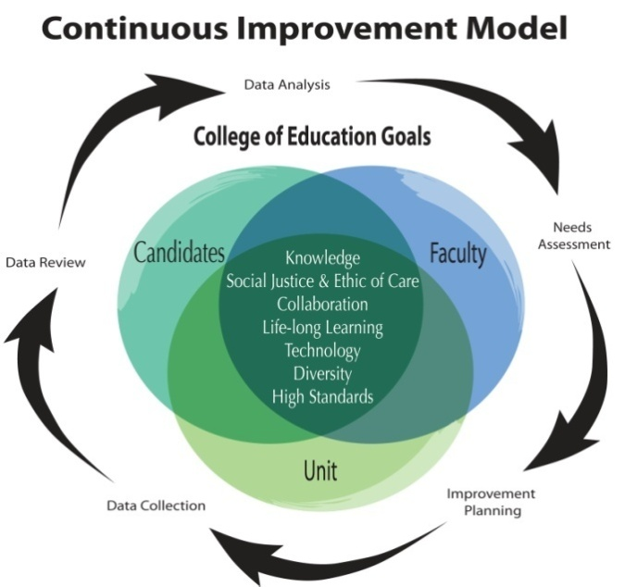

Continuous Improvement Model
The continuous improvement model implemented in the College of Education is highly efficient and effective. All phases of assessment for candidates, faculty, and unit operations occur in parallel, which provides for timely sharing of data necessary to evaluate successes, assess needs, and plan for improvements across the college. As the above graphic illustrates, the process is a continuous cycle in which all five phases occur annually. This facilitates the ability to make timely adjustments when needs are identified.
Candidates are assessed extensively throughout their programs on specific indicators of competence which Include assessment of performance in relation to college proficiencies, program outcomes, state competencies, and national standards. Post graduation surveys with candidates and their employers are also used to assess their professional preparedness, competence, and success as continuous learners and leaders in their fields. All candidate assessments are used by faculty and unit administration to identify needs and plan for improvement.
Faculty assessments also occur within the annual five phase process. Each faculty member reviews candidate and unit data, identifies areas for professional growth in relation to college and professional goals in areas of teaching, scholarship, and service. Each person creates an individual Professional Development Plan, collects performance data, self-assesses achievement, and reviews performance with his/her supervisor. Records of faculty activity and objectives are aggregated and reviewed to inform needs and set objectives at the unit level.
Likewise, the college administration and stakeholders review candidate and faculty assessment data, along with other performance indicators related to the college goals. These data are used to identify needs and develop annual objectives. Data are collected throughout the year and reviewed annually to assess achievement of college objectives. The aggregation, disaggregation, and analysis of this data facilitate college and university level strategic planning and evaluation.
Table 4 presents an overview of the timeline, purpose, and general activities that occur during each phase of assessment of candidates, faculty, and unit operations. Each phase is presented in greater detail in the final section of this document.
Table 4: Phases of the Continuous Improvement Model
Phase 1 – Data Analysis & Needs Assessment (August-September)
Candidate Proficiencies (Program Faculty) | Faculty Expectations (Individual Faculty and Mentors, as applies) | Unit Expectations (College Leadership Team)
Program review of previous year candidate and alumni data. Identify program needs. Results shared with faculty and administration. | Individual faculty review of previous year course assessments, program needs, and previous Annual Review of teaching, scholarship & service. | Administrative review of data on unit operations, program needs, external reports, strategic plan, resources, and faculty needs.
Phase 2 – Improvement Planning (September-October)
Program faculty develop and submit Program Improvement Plans to address candidate needs. Gather input from program advisory boards. | Develop and submit individual Professional Development Plans for teaching, scholarship, & service. | Develop annual College Improvement Plan and update the strategic plan. Gather input from the College Advisory Board.
Phase 3 – Implementation & Formative Assessment (September-April)
Implement program improvement plans and collect formative data on candidate progress. Prepare program revision documents for curriculum committee approval. | Implement professional development plan activities and collect data in areas of teaching, scholarship, and service. | Implement college improvement plan and collect data. Support and monitor data collection for program and faculty development activities.
Phase 4 – Annual Review & Reporting (March-June)
Review formative data and develop the annual Program Review Report describing program accomplishments and submit to faculty, stakeholders, and administration. | Review success in meeting objectives set forth in PDP. Develop an Annual Review involving a portfolio of accomplishments for submission to supervisor. | Review candidate, program, and faculty reports of achievement. Develop Annual College Report and review with College Advisory Board.
Phase 5 – Data Aggregation & Statistical Analysis (June-August)
Aggregate, disaggregate, and analyze candidate performance data in preparation for annual needs assessment. | Aggregate teaching, scholarship, and service data from all faculty across the college. | Aggregate, disaggregate and analyze data related to unit operations in preparation for annual needs assessment.

Data collection, analysis, and evaluation
Through the continuous improvement process, comprehensive information on applicant qualifications, candidate proficiencies, alumni competence, faculty performance, and unit operations are collected, analyzed, and reviewed annually. Data related to candidates’ admission qualifications, their program progress, and their post graduation performance as educators are analyzed at the program level. Results are shared with all college faculty and administration for comprehensive planning and evaluation activities.

Assessment of Candidates
Preparing candidates for their professions is the primary responsibility of the College of Education. Thus, assessments of candidate outcomes are used by faculty and administration for the evaluation and improvement of programs, teaching, and unit operations. Assessments of candidates occur at the time of admission, as they transition through their programs, at the end of their programs, and after they graduate. Multiple assessments are used in each phase of the continuous improvement cycle to obtain a comprehensive picture of candidate performance and program success.
Candidates are monitored from the time they apply to the College of Education, throughout their programs, and after they graduate. The following Transition Point tables depict program requirements and assessments that are used to continually monitor and assess candidates as they enter, progress, and exit programs. These tables also depict specific check points that are used to ensure candidate readiness for subsequent stages of their programs, such as clinical experiences and program completion activities. Following the tables are details regarding assessments and data collected. These are described in the sequence in which assessments are administered and data are collected. Collecting and analyzing data over this extended period enables the college to continually monitor candidate progress, assess needs, and make program improvements.

Fall 2011 – Official ACADEMIC CALENDAR
Colleges submit Fall 2011Course Schedule to Registrar | Monday, November 1
Web Registration begins for Degree Students [1] | Thursday, March 17
In-Person Registration for Degree Students Begins [1] | Monday, April 4
Textbook Order Deadline for Fall 2011 | Thursday, April 14
Post Baccalaureate Non-Degree Registration Begins | Tuesday, June 14
Request Readmission after Indefinite Suspension Deadline | Monday, June 27
Non-Degree Registration Begins [1] | Monday, July 25
Last Day to Mail Payment | Friday, August 12
Classes Begin | Monday, August 22
State Employee Registration Begins [2] | Monday, August 22
Late Registration Begins (late fee assessment begins) | Monday, August 22
Registration for Senior Citizens (Audit mode only-no late fee) | Tuesday, August 23
Payment Deadline | Friday, August 26
Last Day to Drop/Withdraw via Gulfline (100% Refund) | Friday, August 26
Residency Reclassification for Tuition Deadline 5:00 pm | Friday, August 26
Saturday Classes Begin | Saturday, August 27
Cancellation for Non-Payment Begins | Monday, August 29
Labor Day Observed (no classes) | Monday, September 5
Last Day to Withdraw from All Classes for 25% Refund | Friday, September 16
Last Day to Apply for Graduation, No Exceptions | Friday, September 16
Reinstatement with Full Payment Deadline 5:00 pm | Tuesday, October 4
Fall Break (no classes) or Hurricane Make-up Days | Monday, October 10 -  Tuesday, October 11
Last Day to Drop/ Withdraw without Academic Penalty | Friday, November 4
Veteran's Day Observed (no classes) | Friday, November 11
Last Day to Submit Service Learning Hours (graduating seniors) | Monday, November 14
Thanksgiving Observed (no classes) | Wednesday, November 23 -  Saturday, November 26
Regular Class Day | Monday, December 5
Reading Days (no classes) | Tuesday, December 6 -  Thursday, December 8
Last Day of Classes | Friday, December 9
Finals Begin | Saturday, December 10
Finals End/ Last Day of Semester | Friday, December 16
Last Day to Apply for Grade Forgiveness [3] | Friday, December 16
Commencement | Saturday, December 17
Grades Due from Faculty by Noon | Tuesday, December 20

- For priority group registration dates, go to Eagle Registration: http://www.fgcu.edu/Registrar/eagleregistration.html FGCU Employees using Tuition Vouchers can use Eagle Registration according to their priority group.
- State Tuition Waivers may be presented to the Office of the Registrar during this period without late registration fees.
- Last day for undergraduate senior to submit Grade Forgiveness forms if applying for graduation. Grade Forgiveness applications are due from Seniors who have NOT applied for graduation, all Juniors, Sophomores, and Freshmen.
Back
Florida Gulf Coast University reserves the right to repeal, change, or modify any calendar information at any time without advance notice.

ACADEMIC INTEGRITY
On occasion students submit work and misrepresent it as their own. In these instances the students fall under the concern of the Academic Dishonesty Policy. It is found at the website below. If you have concerns that a students may have violated this policy please contact Lois Christensen, Associate Dean; or Sherree Houston, Assistant Dean before contacting the student(s). We will advise you regarding the next steps to take.
http://studentservices.fgcu.edu/judicialaffairs/files/Summary_Adjudication_Form_Information-Revised_August_2009.pdf
Faculty have the opportunity to utilize Turn-It-In as a vehicle to ascertain that material submitted by students is truly their own work.

ANGEL
ANGEL is a course delivery system utilized across the FGCU campus. It provides a mechanism for instructors to structure lessons, add materials, conduct quizzes, facilitate online discussions, and keep track of grades. Most courses in the College of Education have been committed to ANGEL. Training in the use of the program is available from Instructional Technology personnel. In many cases currently structured courses can be made available to adjunct faculty. For immediate use, contact either of the Associate Deans for assistance.

ANGEL Learning Management System and Demonstration Site
Information on ANGEL is available online at http://elearning.fgcu.edu/frames.aspx and
http://elearning.fgcu.edu/section/default.asp?id=xxxDemoonlinecoursestudent.

Attendance
The College of Education strongly urges adjunct faculty to keep attendance records. It is important to monitor the dates students attend class. At the end of the semester the last date of attendance for each student is entered into the final grade screen on Gulfline.

Keeping attendance does not necessarily mean standing in front of the class taking roll. There are numerous methods of taking attendance: exit slips, journal entries, sign in sheets, etc. All are suitable methods for use in higher education. If a student is absent from more than two classes, the instructor should notify the student that continued absence will cause severe consequences. This applies to online classes as well as face-to-face classes. The syllabus should clearly state any consequences related to attendance. Notify the associate dean of any instances in which a concern about lack of attendance occurs.

Class Meetings
Class meetings are scheduled and information regarding class meeting times, sites, and instructor name is available on Gulfline. Except under most unusual circumstances, face-to-face meetings should occur as scheduled on Gulfline. Please refrain from altering the schedule except in an emergency. If such an emergency should occur, be sure the students are adequately notified. Any changes to the published schedule should be made in favor of the student and should not be perceived as punitive in any way.

Copying
The College of Education makes every effort to provide materials to students in electronic format through ANGEL or LiveText. This avoids copying costs and permits easy access for students.
Adjuncts should prepare all necessary material in electronic format. For assistance in converting print to electronic files see the program secretaries (Gil Medina for undergraduate programs and Duska Hepner for graduate programs).

Critical Tasks
All courses in the College of Education feature critical tasks as required assignments. They have been developed through thoughtful review of the course content and the nature of the job for which the candidates are being prepared. For this reason, students must complete them satisfactorily in each course. Reviews for the critical task assignments must be committed to LiveText through the use of the rubric attached to each specific assignment. Critical tasks assignments may not be arbitrarily or unilaterally changed by an instructor. Any suggestions for alteration of the task or its rubric must come to the attention of the Department Chairs.

E-Mail
E-mail accounts for adjunct personnel are activated when materials are processed by Human Resources. The e-mail account will remain active until two weeks following the end of the term for which it was issued. If for any reason you need to have this extended please contact the Administrative Assistant, Bridget Bloomster.

Emergency Procedures
In the event of an emergency, please follow the direction of the University Police Department (UPD) or emergency professional in charge. If an emergency occurs in your classroom, call 1911 from a university telephone, or 911 on your cell phone. To contact the UPD, call 590-1900.

Evaluation Process
To provide for the best possible instruction for our students and to provide ongoing support for adjuncts, we have devised an Adjunct Faculty Evaluation Form. A copy of the form is provided with the Adjunct Orientation Packet. The Associate Dean or Department Chair will schedule one or more observation visits with the adjunct and will review the form with him/her as soon as possible after the observation.
Note: All faculty members are encouraged to utilize mid-term evaluations similar to the SAI evaluations to determine class effectiveness. Such practice can help the instructor to make mid-course adjustments if necessary.

FERPA and University Employee Responsibilities
FERPA is the "Family Educational Rights and Privacy Act of 1974, as amended", and is also known as "The Buckley Amendment".
FERPA is the United States federal law that protects student records privacy and provides for review and disclosure rights. Please review the information linked below, to help you understand FERPA and what it means to you. These pages outline student rights under FERPA to review educational records and to allow or restrict access to third parties.
Please note that some information, called "Directory Information," may be released to third parties without the student's prior consent, unless the student files a written request to restrict directory information access.
For more information on this topic please go to http://www.fgcu.edu/Registrar/ferpa.html.

FGCU Code of Conduct
The FGCU Code of Conduct is available on the FGCU website at http://studentservices.fgcu.edu/judicialaffairs/conduct.html.
This document clearly spells out parameters of acceptable and unacceptable student conduct as well as instructor roles and responsibilities in regard to student conduct. It will be wise for the adjunct to read it carefully. If any situations arise in which there are questions regarding the instructor’s role in the classroom, contact the appropriate Associate Dean.

Grades
A clear grading policy should be noted in the syllabus. Undergraduate program courses use the same grading system for all courses. Grading in graduate courses may vary by instructor.
Grades are due within two days of the end of each semester and are electronically submitted through GULFLINE. FGCU does not automatically mail out grades, these are available to all students through GULFLINE.
The following is information published from the FGCU Catalog:
Grade Point Average Calculation
Florida Gulf Coast University’s grading system includes grades of A, A-, B+, B, B-, C+, C, C-, D+, D, D-, F, I, NR, S, U, W, WF, X, and Z.

It is the option of the college, department or instructor to use all, some, or none of the plus/minus grades in assigning student grades in a course, as long as the grading system is communicated to students via the course syllabi at the beginning of the course. Numerical ranges corresponding to letter grades are established for each course according to the professional judgment of the instructor.
Some colleges, departments, and programs have established minimum grade requirements. In these instances, a grade of C- does not satisfy the requirement of a minimum grade of C, and a grade of B- does not satisfy the requirement of a minimum grade of B. The grades of D+, D, and D-, while considered passing for undergraduate students, may not be acceptable for some courses.

94 - 100% = A
92 - 93% = A-
90 - 91% = B+
84 - 89% = B
82 - 83% = B-
80 - 81% = C+
75 - 79% = C
70 - 74% = D
0 - 69% = F

If you have questions regarding a grade or how to submit grades, discuss the issue with the appropriate Associate Dean.

Grade of “Incomplete”
Contact one of the Associate Deans prior to issuing a grade of Incomplete for any student. FGCU has a policy concerning the use of a grade of “incomplete.” The following is a statement from the 2009-2010 FGCU Catalog:

“Incomplete (I) grade. A student who is passing a course but who has not completed all of the required coursework by the end of the term may, with the permission of the instructor, be assigned a grade of I. A grade of I is not computed in a student’s GPA.

An incomplete (I) grade cannot be assigned to a course if the student fails to attend the course, drops the course after the drop/add period, or withdraws from the university. A student, who registers for a course but fails to meet the course requirements, without officially dropping the course, will receive a grade of F in the course.

To initiate consideration for a grade of I, a student must contact the instructor before grades are reported. The decision to award a grade of I is solely the decision of the instructor. Should a professor decide to assign the grade, both the student and the professor must complete and retain a copy of an Incomplete Grade Agreement Form. The maximum amount of time to complete coursework to remove a grade of I is one year from the ending date of the semester for which the grade was assigned or graduation whichever comes first; however, instructors may restrict the amount of time given to the student to complete the coursework. After one year, a grade of I will be changed to an F if the instructor has reported no grade. A student may not re-register for a course in which he or she currently has an incomplete (I) grade. Once an incomplete (I) grade has converted to a failing grade (F), the grade may not be converted back to an incomplete (I) grade or to a regular grade. Exceptions due to university error may be approved by the College Dean (or his/her designee) with supporting justification attached to a change of grade form.”

Incomplete forms are available electronically or from one of the secretaries in the College of Education. Copies should be provided for the professor, the student, and the student’s file. The student file copy may be given to a COE secretary for processing. A copy of the Incomplete Form is provided at the Adjunct Orientation.

Gulfline/Pin Number
To use GULFLINE you must have a User ID and PIN.
The User ID is a nine digit number beginning with 814. The PIN (Personal Identification Number) will be a six digit number.
Because the PIN acts as electronic signature, and is protected under University policy and Federal law, PIN numbers will not be given out via telephone, fax, or email.

For information on GULFLINE, please follow the links below:
http://www.fgcu.edu/Registrar/files/AllAboutGulfline.pdf
http://www.fgcu.edu/HR/files/Gulfline.pdf

Holiday Schedule
Course assignments and classes are expected to abide by the university calendar. The calendar is available on Gulfline at http://www.fgcu.edu/Registrar/academiccalendar.asp .

Human Resources Department Paperwork and Acquiring Faculty ID Card.
A picture identification card is issued at no cost to employees who have completed the payroll sign-on process. At Florida Gulf Coast University, your ID card is literally, the “key to the kingdom.” With your ID card you will be able to access “Gulfline,” the Intranet web system of FGCU, and classrooms. The card allows you to acquire your parking permit and library resources.
FACULTY/STAFF
- Faculty and staff are eligible for an Eagle ID card upon employment. All employee information must be processed by Human Resources for an employee to receive an Eagle ID card. A VALID government issued photo ID is required to receive an Eagle ID Card.
- Faculty and Staff cards contain door access information and should be treated as keys.
- OPS employees who are not students are also eligible for an Eagle ID card upon employment. All OPS employee information must be processed by Human Resources for an employee to receive an Eagle ID card.
Please report lost or stolen cards immediately! Call (239) 590-7645 between 8:00am and 5:00pm, Monday through Friday: Call Campus Police (239) 590-1900 after normal business hours and on weekends.
For questions, please call (239) 590-SMILE (7645) or e-mail the Eagle ID Card Office at smile@fgcu.edu.

Your ID card will have a nine digit number beginning with 814. You will need this number and the password that you choose to access and log in to GULFLINE. Your password will also be used for logging into to computers on campus. There is a fee for replacement IDs if lost, stolen, or damaged.
The screen shot below shows how the ID card information accesses GULFLINE.

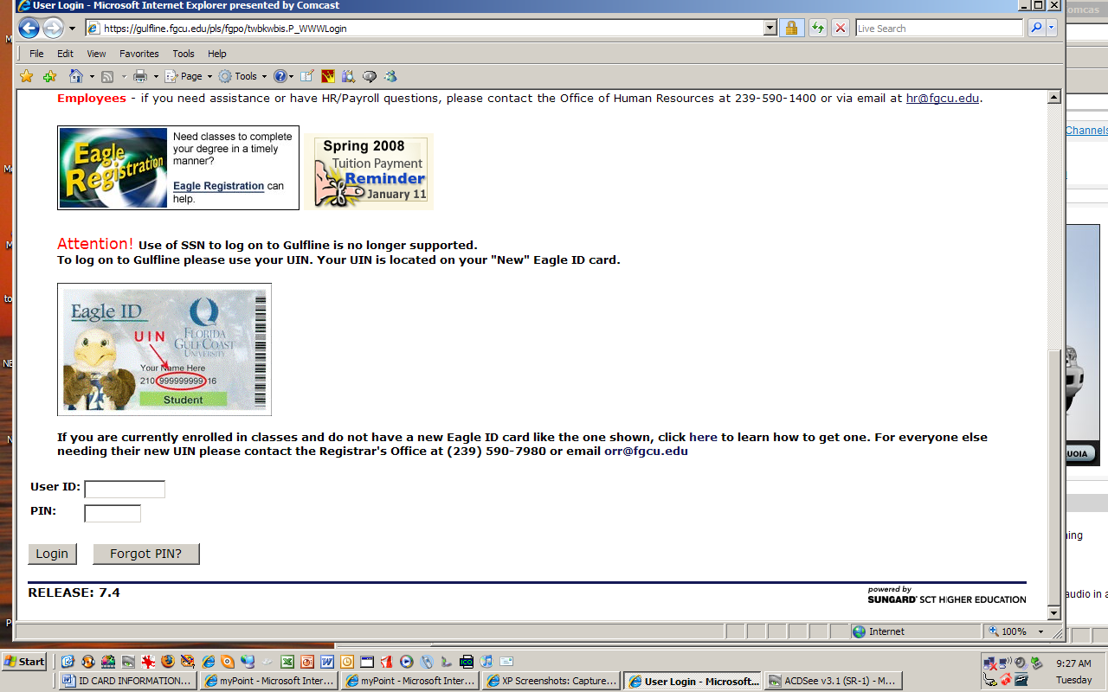
HUMAN RESOURCES SIGN ON

Library Resources
Main page: http://library.fgcu.edu/
Tutorials & Handouts: http://library.fgcu.edu/RSD/Instruction/tutorials.htm
Research Guides: http://fgcu.libguides.com/
Faculty Support: http://library.fgcu.edu/faculty_index.html
Contact Us: http://library.fgcu.edu/LBS/about/contactus.htm

Library Services
Library Services are available to adjunct instructors through the use of the ID card. Materials may be checked out or placed on reserve by instructors.

LiveText
The College of Education has adopted the use of LiveText software to provide for the improvement of student performance and program quality. It may be accessed at http://www.livetext.com. All students in the undergraduate programs have LiveText accounts which are issued at the beginning of Block 1. Students in the graduate programs purchase a LiveText account during the first course in their graduate program.

Most courses in the College of Education have developed critical task assignments linked to standards. The assignments are automatically connected to courses and are visible in both the student and faculty/instructor LiveText accounts. Students are required to submit critical tasks assignments in LiveText at the direction of the instructor. Instructors then review and score the assignments through the LiveText rubric. Standards data are thereby captured and made ready for accreditation reports. LiveText reviews by the instructor should be completed prior to the close of the term.

All faculty and instructors need an active LiveText account. If you do not have one, contact the LiveText Administrator, Roshan Searcy (590-7359), at your earliest opportunity. She will establish your account for you and help you with any questions you may have regarding how to use the program.

While all critical task assignments are submitted to LiveText as a general requirement, other assignments may or may not be submitted in that fashion according to the wishes of the instructor. Faculty/instructors have the ability to add assignments to LiveText, to adjust the due dates for them, and to develop additional rubrics in the program. Critical Tasks must be passed at the 75% level or higher in order for a student to receive a passing grade for the course. For assistance with any of these processes, contact the LiveText Administrator.

Mailboxes
Adjunct mailboxes are available in the copy room. They are located at the south end of the room adjacent to faculty mailboxes.

Office Hours
Adjunct instructors may find it convenient to have office hours before or after class. There is no specifically identified office space for use by adjuncts. See one of the Associate Deans for assistance. In the case of virtual classes, office hours also may be held in virtual fashion as needed.

Office Space
Because of space issues, there is no specific office for adjunct use. However, if you have need to meet privately with a student, contact one of the associate deans or executive secretaries for arrangements.

Parking
Persons employed by Florida Gulf Coast University as adjunct faculty are eligible to obtain a faculty/staff annual parking permit for a charge of $30.00. For instructions, follow the link below to Parking Services
http://www.fgcu.edu/Parking/index.html

To request a permit you must follow the following steps before going to pay and pick up your permit.

- Log onto your Gulfline account at http://gulfline.fgcu.edu
- Click Employee, Parking Services, Request a Permit
- For permit Type, F/S – OPS EMPLOYEE ANNUAL – Fee $30.00 – continue and print the Permit Registration Form. Adjuncts are not eligible for the Payroll reduction plan.
- Once printed bring it along with your employee ID and either a check or $30.00 Cash.

Payroll
A copy of the pay period schedule is available for adjuncts. The first pay date is dependent upon the completion of paperwork through Human Resources. Adjuncts are asked to direct questions on this issue to the executive secretaries. A copy of the payroll schedule is provided at the Adjunct Orientation.

Podium Keys
Podium keys are available from the executive secretaries for the graduate and undergraduate programs.

SAI – Student Evaluation Forms
Student evaluation forms are distributed about three weeks prior to the end of a term. They are to be completed by students according to the schedule that appears on the envelope in which the forms are received. Typically, the instructor leaves the room while the forms are completed. One student takes charge of the completed forms and replaces them in the original enveloped and drops them off at the Library Circulation Desk. Virtual courses also complete SAI forms but do so online. A message is sent to students via ANGEL requesting their completion of the form. Since they are not a captive audience as they would be in a face-to-face situation, it is often difficult to get the forms completed. If you are teaching a virtual section, please remind students to complete the form.

Support Personnel
Gil Medina (590-7776) is the Executive Secretary for the Undergraduate Program.
Duska Hepner (590-7797) is the Executive Secretary for the Graduate Programs.

Syllabus
The College of Education utilizes a standard syllabus format. Adjuncts will receive a copy of a current syllabus for the course they are assigned to teach. Instructors should follow the format but have some discretion to adjust assignments, due dates, the order in which the topics of the course are presented, etc. However, objectives, required field experiences, critical tasks and assessments, and the university calendar schedule cannot be changed. Syllabi must be filed at the beginning of the term with the one of the executive secretaries – Gil Medina for undergraduate courses and Duska Hepner for graduate courses.

The syllabus represents a contract between the instructor and the student. It is the only thing the COE has as defense in issues of student appeals. It should be explicit and extremely clear. Issues related to assignments, requirements, grades, attendance, etc. should be included. It is permissible to include a tentative class assignment schedule, but any changes made to the schedule or any other part of the syllabus must be discussed in advance with students and be in favor of students. To be sure that the syllabus includes all necessary information, follow the suggested guidelines for syllabus design provided by the Office of Academic Affairs. A copy of these guidelines is provided at the Adjunct Orientation.

Text Books
Desk copies of textbooks are ordered for the adjunct faculty. Orders for textbooks are made through “efollett” on GULFLINE by the Associate Deans or program leaders. While teaching for FGCU, adjunct faculty must use the textbooks chosen by the university faculty.

