SPRING 2011
Florida Gulf Coast University
COLLEGE OF EDUCATION - COUNSELING PROGRAM

MADELYN L. ISAACS, PH.D.  Professor, Counseling  239-590-7785 - misaacs@fgcu.edu  AB3 246  SKYPE: madisaacs | Office Hours:  3:00-5:00 on Mondays and 3:00-4:00 on Tuesdays when classes meet and other days by appointment  Anytime via SKYPE

Class location and time: Tuesdays - 05:00 pm - 7:45 pm as scheduled/supervision as arranged

Course Description: This advanced, immersion experience provides students a field based opportunity to integrate advanced clinical and counseling concepts into practice under supervision of site and University-based professionals.

Course Rationale: Sequential field experiences are essential for the pre-professional counselor to integrate theory and practice. This course provides the necessary practice for partially fulfilling requirements for becoming a licensed mental health counselor in the state of Florida.

Course Objectives:
To actively engage students in practicing the process, procedures, skills, and knowledge related to contemporary practice in community and clinical mental health settings.

The Council for the Accreditation of Counseling and Related Educational Programs (CACREP)

      - HELPING RELATIONSHIPS - studies that provide an understanding of counseling and consultation processes, including all of the following:
5.A. counselor and consultant characteristics and behaviors that influence helping processes including age, gender, and ethnic differences, verbal and nonverbal behaviors and personal characteristics, orientations, and skills;
5.D. a systems perspective that provides an understanding of family and other systems theories and major models of family and related interventions. Students will be exposed to a rationale for selecting family and other systems theories as appropriate modalities for family assessment and counseling;
5.E. a general framework for understanding and practicing consultation. Student experiences should include an examination of the historical development of consultation, an exploration of the stages of consultation and the major models of consultation, and an opportunity to apply the theoretical material to case presentations. Students will begin to develop a personal model of consultation;
5.F. integration of technological strategies and applications within counseling and consultation processes; and
5.G. ethical and legal considerations.

      - 6.0: GROUP WORK - studies that provide both theoretical and experiential understandings of group purpose, development, dynamics, counseling theories, group counseling methods and skills, and other group approaches, including all of the following:

6.E. approaches used for other types of group work, including task groups, psychoeducational groups, and therapy groups;

      - 7.0. ASSESSMENT - studies that provide an understanding of individual and group approaches to assessment and evaluation, including all of the following:

7.A. historical perspectives concerning the nature and meaning of assessment;
7.B. basic concepts of standardized and nonstandardized testing and other assessment techniques including norm-referenced and criterion-referenced assessment, environmental assessment, performance assessment, individual and group test and inventory methods, behavioral observations, and computer-managed and computer-assisted methods;
7.C. statistical concepts, including scales of measurement, measures of central tendency, indices of variability, shapes and types of distributions, and correlations;
7.D. reliability (i.e., theory of measurement error, models of reliability, and the use of reliability information);
7.E. validity (i.e., evidence of validity, types of validity, and the
relationship between reliability and validity;
7.F. age, gender, sexual orientation, ethnicity, language, disability, culture, spirituality, and other factors related to the assessment and evaluation of individuals, groups, and specific populations;
7.G. strategies for selecting, administering, and interpreting assessment and evaluation instruments and techniques in counseling;
7.H. an understanding of general principles and methods of case conceptualization, assessment, and/or diagnoses of mental and emotional status; and
7.I. ethical and legal considerations.

CACREP Standards

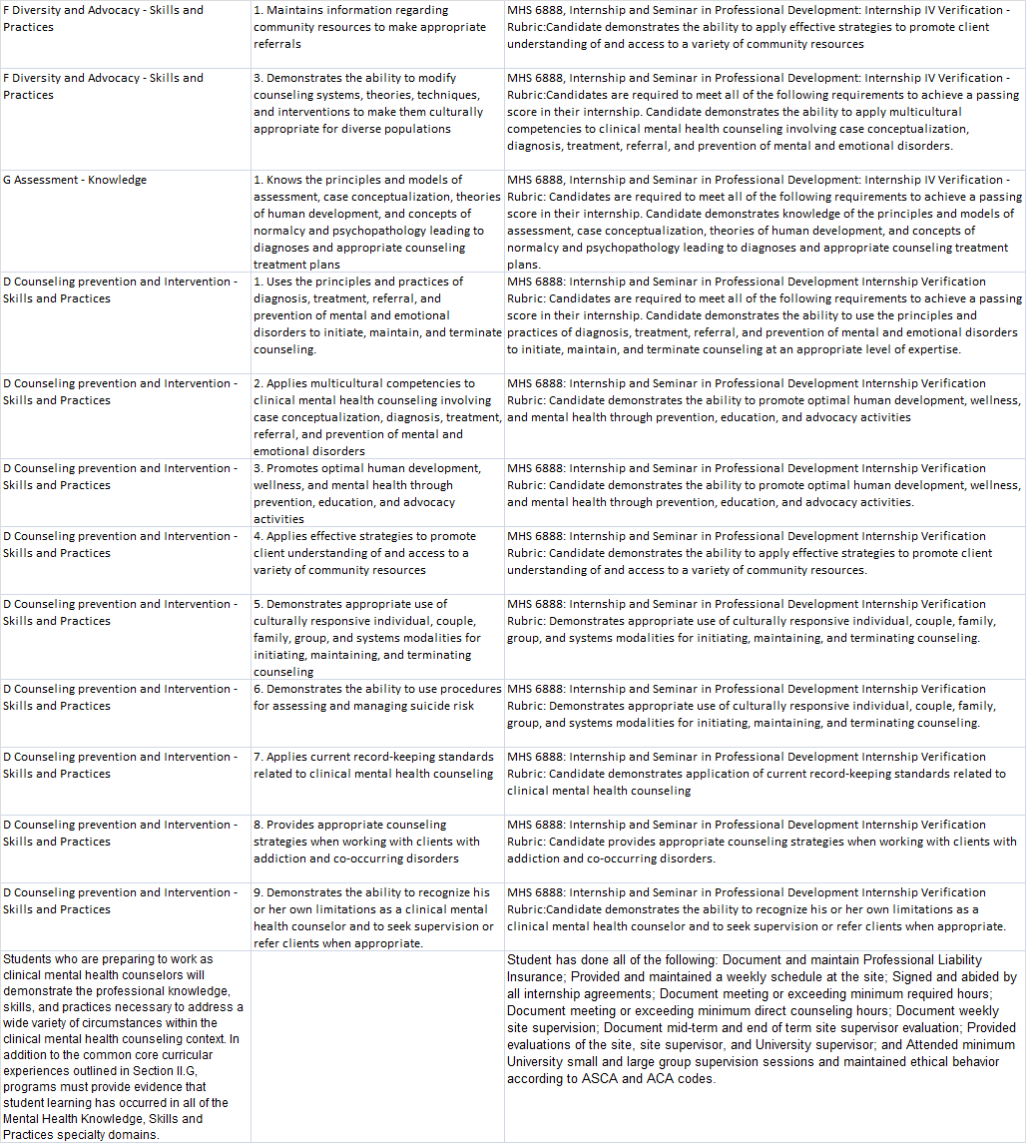

University Outcomes

- Excellence in critical thinking, problem-solving, analysis, and strategic planning
- Effective use of a variety of communication skills and modalities
- Professional and technical expertise consistent with discipline and/or content area specific accrediting or licensing bodies
- Preparation for leadership roles in professional and occupational areas and in communities in which they live and work
- The capacity for continuing learning, growth, and scholarly activity in their respective disciplines and fields of study.

PRIMARY METHODS OF INSTRUCTION
Included? Y/N | Method Type | Description
X | Analysis and Reflection | Reflection on practice is of importance because it enables practitioners to assess, understand and learn through their experiences. A positive active process of reflection that reviews, analyses and evaluates experiences draws on theoretical concepts and previous learning and so provides an action plan for future experiences.
 | Artifacts (i.e., audio tape/video) | Audio and/or video recorded lessons are used for analysis, annotation and reflection on counseling concepts that are being put into practice.
 | Cooperative Learning Activities | Cooperative learning is a generic term for various small group interactive instructional procedures. Students work together on academic tasks in small groups to help themselves and their teammates learn together.
X | Large/Small Group Discussion | Group work provides opportunities for intellectual and personal growth that cannot be achieved so easily in the standard lecture situation. It provides opportunities for interaction between students and among students.
 | Lecture | The lecture is a teaching method where an instructor is the central focus of information transfer. Lectures are a straightforward way to impart knowledge to students quickly.
X | Role Play | Role-playing refers to the changing of one's behavior to assume a role, either unconsciously to fill a social role, or consciously to act out an adopted role.
 | Virtual/Online | The entire course is taught online with possibly a maximum of one or two face to face meetings.
 | Web Based Activity | Web based activities tend to provide information resources for students and/or help to create a richer learning environment that includes activities, resources, and assessment.
x | Field Experience Course | The course is primarily designed to provide practicum or internship experiences and supervision.
 | Guest Speakers/Field Trips | The course includes one or more guest speakers or trips to external sites (on an individual or group basis) to support learning from experts or examples from the field.

Implementation Strategies:

    - This class is structured to provide guided field experience at a level commensurate with current training in the program. Students will be oriented by the university faculty to the field experience requirements.
    - No specific bibliographic material is planned beyond that used in the course of both group and individual supervision.

Coursework Activities: You will be responsible for

  - Observing, participating in, co-leading and leading various activities related to the practice of counseling in a community and clinical mental health setting. Such activities include assisting clients by providing individual and group counseling, consultation, advocacy, assessment and diagnosis, treatment planning, and other activities that support client treatment and progress consistent with the parameters of the agency/site and best professional practices.
  - Sharing with your classmates audio and/or video tapes of your work and periodically providing and receiving peer feedback.
  - Leading and participating in discussions pertaining to counseling issues.
  - Engaging in all aspects of client treatment including initial assessment, resources coordination and referral, assessment, treatment planning and providing clinical interventions as appropriate.
  - Completing all required paperwork.
  - Maintaining liability insurance and practicing with utmost legal and ethical behavior (professionalism);
  - Becoming oriented to the agency (building, grounds, administration, secretarial, programs, etc.)
  - Maintaining a counseling schedule;
  - Attending in-service training sessions, if available;
  - Leading groups;
  - Collegial and cross-disciplinary consultation; and
  - Monitoring effectiveness;

Representative Internship Experiences

Perform all duties as a counselor. Develop a caseload and weekly schedule. Begin by outlining goals and expectations for the internship, discuss these with the site and faculty supervisors. Identify minimum desired experiences for the semester, including some in areas that were not included in practica and/or prior internships.

  - Individual Counseling. Attention given to those who cannot discuss their problems or function well in a group.
  - Group Counseling. Try some new kinds of groups (e.g. relaxation, death and separation, assertiveness, circles, problem-centered, career decision making, etc.)
  - Providing consultation to families and others about the case (receiving consultation from other professionals about a vase is not your direct service.)
  - Intake/Assessment and Diagnosis

Site Supervisors

  - Negotiate student internship hours and responsibilities.
  - Orient the student to the mission, goals, and objectives of the site, as well as to internal operation procedures.
  - Develop goals and objectives with the student for his/her experience early in the semester.
  - Are trained by the university and is familiar with the FGCU Graduate Candidate and Site Supervisor's Manual, and has appropriate supervisor's training
  - Ensure that the student has appropriate experience(s) during the placement based on student's goals and objectives.
  - Meet and document weekly supervision for at least one-hour each week.
  - Provide a written evaluation of the student's performance at mid-semester and at the end of the placement. Evaluations are to be submitted to the student's university supervisor.
  - Maintain contact with university supervisors for assistance and consultation relating to student's progress.
  - Engage in ongoing assessment of the student's performance and communicates with the university supervisor about any problems with the student's performance. If problems continue, the site supervisor, in consultation with the student and university supervisor, will develop a remediation plan.
  - Are available to meet with the university supervisor at least once per semester.
  - Maintain confidentiality (with the exception of the university supervisor) regarding information obtained during supervision with the student.

University Supervisors

Provide guidance and assistance to the site supervisor as needed.
Approve student's goals and objectives to be pursued at site.
Explain the requirements of the experience and provides pertinent information.
Consult with site supervisor about the student's progress and encourages site supervisors to contact the university supervisor for assistance and consultation during the semester.
Provide supervision to the students in individual and/or group supervision throughout the semester.
Review work samples (audio/video tapes) of the student's fieldwork.
Appropriately maintain confidentiality about information obtained during supervision.
Plan conferences with the site supervisor for final assessment of the student's progress.
Collect logs and supervisor evaluations from each student.
Complete a written evaluation for each student.
Submits all evaluations and logs to Coordinator at the end of term.
Assign grades to students for the practicum and internship experience.

Time Requirements

Internship spans 300 hours, 120 of which are in direct service to clients and other stake holders. Experience must be focused and balanced among all roles/responsibilities of a mental health counselor.

Important Notes

    - Class Attendance. The classroom format is largely experiential. It is not possible to make up the experiences of demonstration, supervision, discussion, and feedback done in class. In order for maximum learning to occur, you must attend class and supervision regularly. Supervision must be completed as arranged (alternate arrangements can be made on an individual basis.) There are relatively few group sessions thus all are required to complete the course. You must be in class from beginning to end on a given day. It is expected that any assigned readings be completed prior to class in order to maximize class discussions. During class, relevant questions, pertinent comments, and risk taking in modeling are welcomed and encouraged.

    - Confidentiality. Protecting confidentiality is the cornerstone of our profession. You are expected to protect the information and identity of any client you work with as specified and limited by ethical standards (ACA and AMHCA and or ASCA) and relevant state and Federal laws. In some situations, class participants can sometimes serve as clients, counselors and peer supervisors. As a result, confidentiality regarding client issues is mandatory. Thus it is a baseline expectation that you will not carry personal information out of this class. Student school counselors are also expected to follow the Florida Standards for Professional Practice.
Furthermore, students will be required to record, with appropriate permission and informed consent, counseling sessions for evaluation by site, university and peer supervisors. This will be done using digital recording equipment and exchange of recordings using YouSendIt.com. Please register on Yousendit if you do not already have an account and familiarize yourself with how to readily send your digital recordings.
Evaluation. Evaluation of your performance is strictly on a Pass/No Pass basis. To successfully complete the course, you will need to meet minimum levels of competencies for all assignments as determined against a rubric of performance levels.
4. Technology: Technological proficiency is a must for all counselors. All students must have competence to set up and use a word process, process email, search and navigate the web, and use other software such as PowerPoint and Excel. Technological support is available to you at the University’s Library (go to http://library.fgcu.edu and look at the Instruction and Training menu). Furthermore, students will be required to record, with appropriate permission and informed consent, counseling sessions for evaluation by site, university and peer supervisors. This will be done using digital recording equipment and exchange of recordings using YouSentIt.com. Please register on Yousendit if you do not already have an account and familiarize yourself with how to readily send your digital recordings.
5. Proficiency in the Use of Oral and Written Standard English is expected of all students. All papers and projects are expected to reflect Standard English grammar, spelling, punctuation, and appropriate vocabulary and sentence structure and utilize APA form and style when appropriate.
6. Professional Liability Insurance: If you have not already done so, you will need to obtain and provide proof of professional liability insurance. Or, you may contact your homeowner insurance provider for an appropriate rider. You will need a minimum of $1,000,000/$2,000,000 protection although more is recommended. A copy of that policy must be presented to the University Supervisor at the beginning of the term.
7. Background Check: some mental health counseling agencies require anyone who interacts with clients to undergo a state and/or federal background check. You may need to do this right away as explained in class. Or visit http://tinyurl.com/7edau for more detailed information.

8. Academic Behavior Standards and Academic Dishonesty
All students are expected to demonstrate honesty in their academic pursuits. The university policies regarding issues of honesty can be found in the FGCU Student Guidebook under the Student Code of Conduct and Policies and Procedures sections. All students are expected to study this document which outlines their responsibilities and consequences for violations of the policy. The FGCU Student Guidebook is available online at http://studentservices.fgcu.edu/judicialaffairs/new.html

- Disability Accommodations Services
Florida Gulf Coast University, in accordance with the Americans with Disabilities Act and the university’s guiding principles, will provide classroom and academic accommodations to students with documented disabilities. If you need to request an accommodation in this class due to a disability, or you suspect that your academic performance is affected by a disability, please contact the Office of Adaptive Services. The Office of Adaptive Services is located in Howard Hall 137. The phone number is 239-590-7956 or TTY 239-590-7930

- Student Observance of Religious Holidays

All students at Florida Gulf Coast University have a right to expect that the University will reasonably accommodate their religious observances, practices, and beliefs. Students, upon prior notification to their instructors, shall be excused from class or other scheduled academic activity to observe a religious holy day of their faith. Students shall be permitted a reasonable amount of time to make up the material or activities covered in their absence. Students shall not be penalized due to absence from class or other scheduled academic activity because of religious observances. Where practicable, major examinations, major assignments, and University ceremonies will not be scheduled on a major religious holy day. A student who is to be excused from class for a religious observance is not required to provide a second party certification of the reason for the absence.

CRITICAL NOTES:

- You cannot begin your experience without first obtaining professional liability insurance, and in some cases, successfully passing a background check. You will need to provide me with documentation as evidence for both.
- Without exception, your site supervisor or appropriate designee must be on the premises when interacting with client(s).
- You must attend any orientation or other activities as determined by the site before starting.
- You are responsible for logging all your hours and activity with accompanying signatures. A copy of your log must be submitted to complete the course. Everyone must use the Excel spreadsheet (obtained online at http://coe.fgcu.edu/counseling/internship/internship-hours-log.xls) to log your hours.
- Download and read the internship manual by visiting the COE website.

Summary Checklist of Internship Requirements

Description | Satisfactory | Unsatisfactory
Completed Plan and Information Forms
COPY of Professional Liability Insurance
Attendance
Weekly Schedule
300 total hours
40% of hours (120) in direct contact with clients
40% of direct contact/10% total hrs (30-48 hrs) group
Weekly Class Activities
Licensure Application Packet
Submitted and Reviewed Required Recorded Hours
Weekly Site Supervision
Site supervisor evaluation (Site Supervisor)
Mid intern feedback/eval (Isaacs)
Final intern eval (Isaacs)
Cumulative Log of Activity (in Excel)
Approximately 5 samples of audio or video tapes (class or submitted) no less than 30 minutes each. No more than two tapes for any one case. Demonstration of competence in planning and implementing intervention in at least three identified counseling theories.

Schedule of Supervision

Date | Class Schedule | 4-4:50pm | 4:55-5:45 | 5:55 - 6:45 | 6:55 – 7:45
Jan 11 | Group Supervision
Week of Jan 18 | Meet as individuals/dyads during class or as scheduled
Jan 25 | Group Supervision
Week of Jan 31 | Meet as individuals/dyads during class or as scheduled
Week of Feb 7 | Peer Supervision Exchange Tapes as scheduled with feedback to partner and Isaacs
Feb 15 | Group Supervision
Week of Feb 21 | Group Supervision
February 28 and March 14 | Individual Supervision at sites as arranged
Weeks of Mar 7 | Spring Break
Mar 22 | Peer Supervision Exchange Tapes as scheduled with feedback to partner and Isaacs
Week of March 28 | Group supervision
Week of April 5 | INDIVIDUAL/Dyadic SUPERVISION DURING CLASS OR AS SCHEDULED
April 12 | Group supervision
April 19 | Group and Final Individual Meetings as arranged – Submit all final paperwork

Individual/dyad supervision schedule or as scheduled
Weeks of 1/18, 1/31, 2/28 or 3/14, 4/5
Tuesday evening or at other time of week as scheduled:
4:00-4:50 4:55-5:45 5:55-6:45 6:55-7:45

Weeks of 2/28 and 3/14 – individual supervision coordinated with site visits.

Standards Matrix

