 **Syllabus for Course Reference MHS 6200**

**General Course Information**

**Spring 2012**

**CRN 10755 Course Number: MHS 6200**

**Course Title: Appraisal Procedures for Counselors Credit Hours: 3**

CLASS TIME: Tuesday 5:00-7:45pm LOCATION: AB 5-335

Instructor: Abbe′ Finn, Ph.D., LPC

**Office Phone: 590-7772 Email: afinn@fgcu.edu**

**Office Hours: AB3 281 Mon., Tues, Wed., 2-4.**

**If you cannot come during the above office hours please arrange an appointment. I will also be available for questions or concerns after class.**

**Required Text:** Whiston, S., (2009), *Principles and Application of Assessment in Counseling, 3rd. Edition.* Belmont, CA:Brooks/Cole.

Manuals of the instruments used for assessments are available through the reserve section of the library.

## Course Description

A Study of test and non-test techniques of appraisal with emphasis on the use of test data in counseling programs. Focus will be on integrating data from a variety of sources at individual small group, and large group levels.

II. **Objectives:**

By course completion candidates will be able to:

1. Demonstrate a knowledge of principles of conducting an intake interview and mental health history for planning counseling interventions (CACREP Standard II, K-5: b)
2. Demonstrate knowledge and understanding of at least five (3) paper-pencil tests from the following areas of human assessment:

1. Achievement

2. Aptitude

3. Mental ability (intelligence)

4. Interest

5. Personality

1. Core CACREP Standards met:

Section II-G. 7. ASSESSMENT—studies that provide an understanding of individual and group approaches to assessment and evaluation in a multicultural society, including all of the following:

a. historical perspectives concerning the nature and meaning of assessment;

b. basic concepts of standardized and nonstandardized testing and other assessment techniques, including norm-referenced and criterion-referenced assessment, environmental assessment, performance assessment, individual and group test and inventory methods, psychological testing, and behavioral observations;

c. statistical concepts, including scales of measurement, measures of central tendency, indices of variability, shapes and types of distributions,and correlations;

d. reliability (i.e., theory of measurement error, models of reliability, and the use of reliability information);

e. validity (i.e., evidence of validity, types of validity, and the relationship between reliability and validity);

f.social and cultural factors related to the assessment and evaluation of individuals, groups, and specific populations; and

g. ethical strategies for selecting, administering, andinterpreting assessment and evaluation instruments and techniques in counseling.

1. Core CACREP Mental Health Standards Met:

G1:Knows the principles and models of assessment, case conceptualization, theories of human development, and concepts of normalcy and psychopathology leading to diagnoses and appropriate counseling treatment plans;

G.2: Understands various models and approaches to clinical evaluation and their appropriate uses, including diagnostic interviews, mental status examinations, symptom inventories, and psychoeducational and personality assessments;

G.4: Identifies standard screening and assessment instruments for substance use disorders and process addictions

H.1: Selects appropriate comprehensive assessment interventions to assist in diagnosis and treatment planning, with an awareness of cultural bias in the implementation and interpretation of assessment protocols;

H.2: Demonstrates skill in conducting an intake interview, a mental status evaluation, a biopsychosocial history, a mental health history, and a psychological assessment for treatment planning and caseload management;

H.3: Screens for addiction, aggression, and danger to self and/or others, as well as co-occurring mental disorders

1. CACREP School Counseling Standards met:

H.1:Assesses and interprets students’ strengths and needs, recognizing uniqueness in cultures, languages, values, backgrounds, and abilities.

H.2: Selects appropriate assessment strategies that can be used to evaluate a student’s academic, career, and personal/social development.

H.3: Analyzes assessment information in a manner that produces valid inferences when evaluating the needs of individual students and assessing the effectiveness of educational programs.

1. **For School Counseling Graduate Students:**

FEAP Indicators

1.1 Demonstrates knowledge of traditional and non-traditional assessment strategies appropriate to all students.

1.2 Employs a variety of assessment strategies congruent **with** school counseling program standardsto determine PK-12 students’ behavior change.

1.3 Interprets data from various traditional and non-traditional assessments, including FCAT results.

8.1 Knows and understands the school counselor’ssubject matter thoroughly.

**II.A PRIMARY METHODS OF INSTRUCTION**

|  |  |  |
| --- | --- | --- |
| **Included? Y/N** | **Method Type** | **Description** |
| x | Analysis and Reflection | Reflection on practice is of importance because it enables practitioners to assess, understand and learn through their experiences. A positive active process of reflection that reviews, analyses and evaluates experiences draws on theoretical concepts and previous learning and so provides an action plan for future experiences. |
|  | Artifacts (i.e., audio tape/video) | Audio and/or video recorded lessons are used for analysis, annotation and reflection on counseling concepts that are being put into practice. |
| x | Cooperative Learning Activities | Cooperative learning is a generic term for various small group interactive instructional procedures. Students work together on academic tasks in small groups to help themselves and their teammates learn together. |
| X | Large/Small Group Discussion | Group work provides opportunities for intellectual and personal growth that cannot be achieved so easily in the standard lecture situation. It provides opportunities for interaction between students and among students. |
| x | Lecture | The lecture is a teaching method where an instructor is the central focus of information transfer. Lectures are a straightforward way to impart knowledge to students quickly. |
| x | Role Play | Role-playing refers to the changing of one's behavior to assume a role, either unconsciously to fill a social role, or consciously to act out an adopted role. |
|  | Virtual/Online | The entire course is taught online with possibly a maximum of one or two face to face meetings. |
|  | Web Based Activity | Web based activities tend to provide information resources for students and/or help to create a richer learning environment that includes activities, resources, and assessment. |
|  | Field Experience Course | The course is primarily designed to provide practicum or internship experiences and supervision. |
|  | Guest Speakers/Field Trips | The course includes one or more guest speakers or trips to external sites (on an individual or group basis) to support learning from experts or examples from the field. |

## COURSE REQUIREMENTS AND ASSESSMENT PROCEDURES

**A. Course Requirements**

1. Class attendance and participation. Please attend all class meetings on time. Students are expected to have read the assigned text, and to maintain a current reading status on handouts and/or other reading assignments. **(5 points)**

1. **Field Experience and Clinical Practice**

Candidates will administer and interpret five assessments instruments including a structured clinical interview. Students will complete written analysis and reports. **(5 at 9 pts. Each = 45 Points Florida EAP 1) See the rubrics on file through Angel.** For School Counseling Program candidates, two assessments must be conducted on school aged children. Standards met CACREP School H1-H3. Standards met CACREP CMHC H1-H3.

**The reports will include the following sections:**

**a. Demographics**: Fictitious name of client/ accurate demographic information such as gender, date of birth.

**b. Relevant background information**.

**c. Type of instrument used**

**d. For standardized tests**: Information about the instrument. Name, Author, Publisher, date of publication, Validity, reliability, standard error of measurement, composition of norming population, and limitations of this instrument.

**e. Findings**: raw data and scaled scores.

**f. Impact on learning or functioning**. Clinical Impression

**g. Recommendations** (treatment or educational)

**h. Reflection** by the counseling candidate regarding the use, and interpretation of the instrument

1. Quizzes in the first 10 minutes of class worth 4 points. If 11 are completed, the lowest score will be dropped. (Florida EAPs 1,5,& 6)(CACREP Core Standards 7 a-g; CACREP CMHC Standards met: G.1-G.4) **( 40 Points).** Except under very unusual circumstances, these quizzes cannot be made up later.
2. In class Final **(10 pts) CACREP Core Standards 7.a-7.g see section C above, CMHC G.1-G.4.**
3. School Counseling students are required to demonstrate the following requirements in order to pass the course:

FEAP Indicators # 1.1; 1.2; and 1.3 (See Above).

###### Assessment Procedure

Three assessment procedures will be used to determine candidate achievement of the course objectives listed under VI. All required assignments will be given a specific point value. Points will be totaled and grades will be computed using the following scale:

A = 93 - 100%,

B = 84 - 92%

C = 76 - 83 %

D = 69 – 75 %

F = Below 69

1. **Instructional Strategies:**

Candidates will receive instruction through

* + 1. Lecture
    2. Class discussion
    3. Demonstrations
    4. Role-plays
    5. Lab work (i.e. administration of five assessments including a structured interview).

**D. Attendance Policy**

Attendance Policy: Attendance and participation in class are expected.

More than one absence per semester may adversely affect the final grade for the course. Candidates are responsible for all material covered when absent. If more than two absences occur, the student may fail the course.

**Confidentiality.**

Protecting confidentiality is the cornerstone of our profession. You are expected to protect the information and identity of any client you work with as specified and limited by ethical standards (ACA and AMHCA and or ASCA) and relevant state and Federal laws. In some situations, class participants can sometimes serve as clients, counselors and peer supervisors. As a result, confidentiality regarding client issues is mandatory. Thus it is a baseline expectation that you will not carry personal information out of this class. Student school counselors are also expected to follow the Florida Standards for Professional Practice.

**Furthermore, students will be required to record, with appropriate permission and informed consent, counseling sessions for evaluation by site, university and peer supervisors.** This will be done using digital recording equipment and exchange of recordings using YouSendIt.com. Please register on Yousendit if you do not already have an account and familiarize yourself with how to readily send your digital recordings.

## COURSE OUTLINE Assignments and Assessments

| Date | **Topic** | **Readings and Assignments** |
| --- | --- | --- |
| 1/10/12 | Course overview;  Assessment in Counseling | 1 |
| 1/17/12 | Basic Assessment Principles | 2 |
| 1/23/12 | Reliability | 3 |
| 1/31/12 | Validity and Item Analysis | 4 |
| 2/7/12 | Initial Assessment in Counseling  Using Assessment in Counseling | 6  13 |
| 2/14/12 | Selecting, Administering, Scoring, and Communicating Assessment Results  Ethical and Legal Issues in Assessment | 5  14 |
| 2/21/12 | Intelligence and General Ability Testing | 7  **Intake Assessment Report Due** |
| 2/28/123 | Assessment of Achievement and Aptitude: Applications in Counseling | **8** |
| 3/6/12 | Spring Break | No class meeting |
| 3/13/12 | Assessment in Career Counseling | 9 |
| 3/20/12 | Appraisal of Personality | 10  **Academic Aptitude Due** |
| 3/27/12 | Clinical Assessment | 13  Personality Inv. Due |
| 4/3/12 | Assessment in Marriage and Family Counseling | 11 |
| 4/10/12 | Assessment and Diagnosis | 12  Assessment of Choice Due |
| 4/17/12 | Issues Related to Assessment with Diverse Populations | 15  Assessment of Choice Due |
| 4/24/12 | In Class Scheduled 7:30-10:15 pm | Final Examination |

## CLASS POLICIES

As a part of this classroom community of learners, please be prepared to participate and share your thoughts, feelings and questions related to the assigned readings. Absences will result in grade penalty.

Format for Written Assignments

All Assignments must be typed or printed from a word processor in APA format. Your name must appear and all multi-page documents must be stapled. Papers are due on the date published in the syllabus unless changed by the professor. There will be reduction of points for late papers. All papers are due at the beginning of class on the assigned date.

**University Statements:**

Incomplete (I) Grade:

“A student who is passing a course but who has not completed all of the required coursework by the end of the term may, with the permission of the instructor, be assigned a grade of I. A grade of I is not computed in a student’s GPA.

“An incomplete grade cannot be assigned to a course if the student fails to attend the course, drops the course after the drop/add period, or withdraws from the university. A student who registers for a course but fails to meet the course requirements, without officially dropping the course, will receive a grade of F in the course.

“To initiate consideration for a grade of I, a student must contact the instructor before grades are reported. The decision to award a grade of I is solely the decision of the instructor. Should a professor decide to assign the grade, both the student and the professor must complete and retain a copy of an Incomplete Grade Agreement Form. The maximum amount of time to complete coursework to remove a grade of I is one year from the ending date of the semester for which the grade was assigned or graduation, whichever comes first; however, instructors may restrict the amount of time given to the student to complete the coursework. After one year, a grade of I will be changed to an F if the instructor has reported no grade. A student may not re-register for a course in which he or she currently has an incomplete (I) grade.”

Academic Dishonesty/Cheating Policy:

"All students are expected to demonstrate honesty in their academic pursuits. The university policies regarding issues of honesty can be found under the "Student Code of Conduct" on page 11, and under "Policies and Procedures" on pages 18 - 24 of the Student Guidebook . All students are expected to study this document, which outlines their responsibilities and consequences for violations of the policy. "

Disability Accommodations Services:

Florida Gulf Coast University, in accordance with the Americans with Disabilities Act and the university's guiding principles, will provide classroom and academic accommodation to students with documented disabilities. If you need to request accommodation in this class due to a disability, or you suspect that your academic performance is affected by a disability, please see me or contact the Office of Multi Access Services. The Office of Multi Access Services is located in the Student Services building, room 214. The phone number is 590-7925 or TTY 590-7930.

**Student Observance of Religious Holidays**

All students at Florida Gulf Coast University have a right to expect that the University will reasonably accommodate their religious observances, practices, and beliefs.  Students, upon prior notification to their instructors, shall be excused from class or other scheduled academic activity to observe a religious holy day of their faith. Students shall be permitted a reasonable amount of time to make up the material or activities covered in their absence. Students shall not be penalized due to absence from class or other scheduled academic activity because of religious observances. Where practicable, major examinations, major assignments, and University ceremonies will not be scheduled on a major religious holy day. A student who is to be excused from class for a religious observance is not required to provide a second party certification of the reason for the absence.

Please notify the professor in advance for an accommodation.

**Standards Matrix**

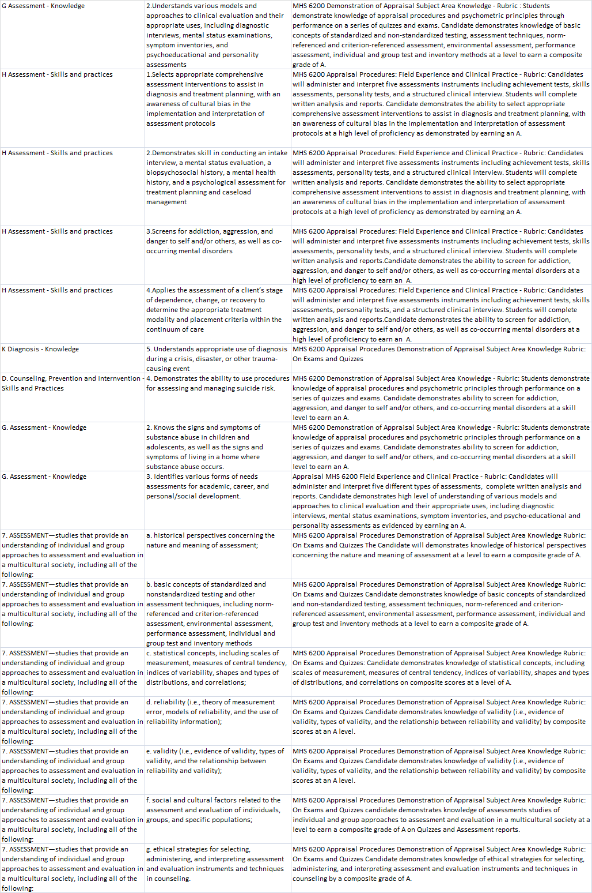

Assignments: All assignments are due on the date stated in the syllabus unless otherwise stated by the professor. Any work turned in late (after the start of class) will lose two points per day. (For example, an assessment turned in two days late will have a maximum number of points of 5 rather than 9 points).

### Flexibility Clause

The aforementioned requirements, assignments, policies, evaluation procedures, etc. are subject to change. Candidates' experiences and needs, as well as emerging knowledge, will be considered in modifying this course syllabus.

CANDIDATE INFORMATION

Course name and number: ________________________________________________

Name: _________________________ Student I.D #_______________________

Gender _____________ Race: ______________

Home Phone #: ___________________ Work Phone #: ________________

e-mail Address: ______________________ Number of hours this semester: _____

Number of hours working this semester: __________

Home Address: ____________________________________________________

Fax#: ________________________ Emergency Contact: _____________

Goal Degree: _________________

Major: _______________________________________

What type of work do you do? _________________________________________

Goal for taking this course: ____________________________________________