Appendix 10.0 Evidence of Program Mission on Public/On-line Resources.

Counseling Program Blog

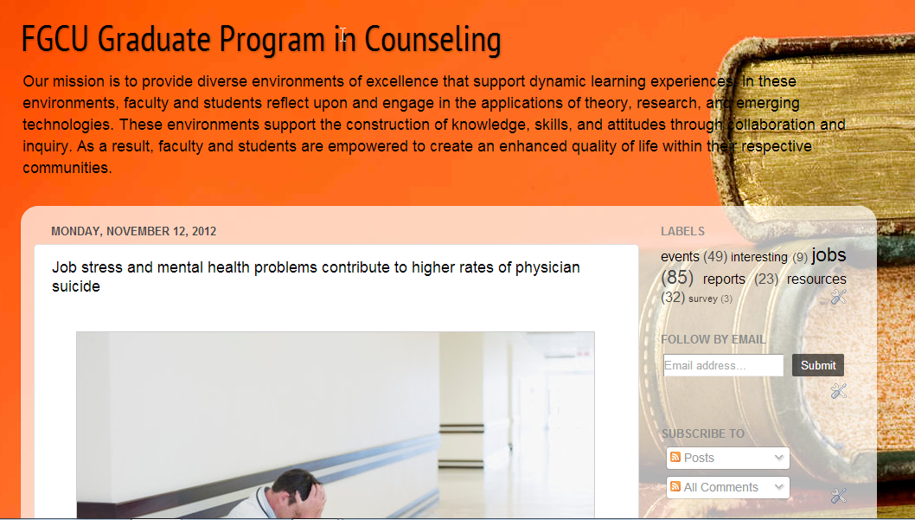

<http://coe.fgcu.edu/schoolcounselingma/index.asp>

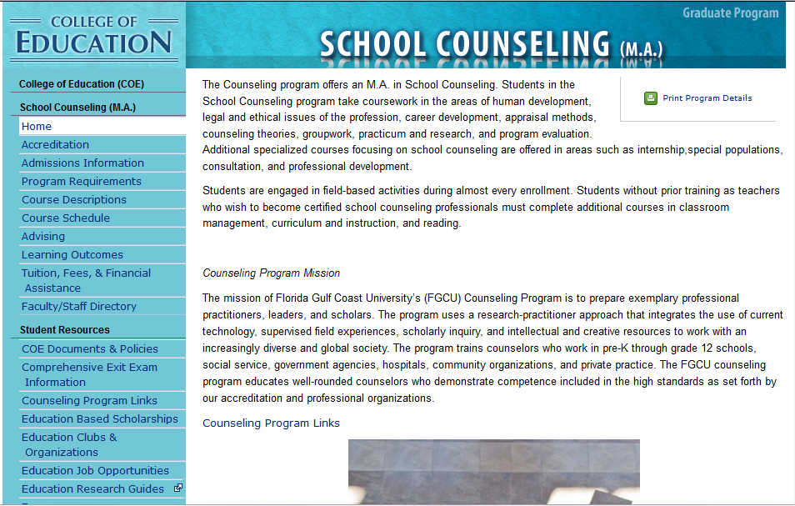

From <http://coe.fgcu.edu/mentalhealthma/index.asp>

